Show Jumping Competition

At

Hafod Equestrian Arena. Trefnant. LL16 4UN

On

Sunday 2nd April 2023

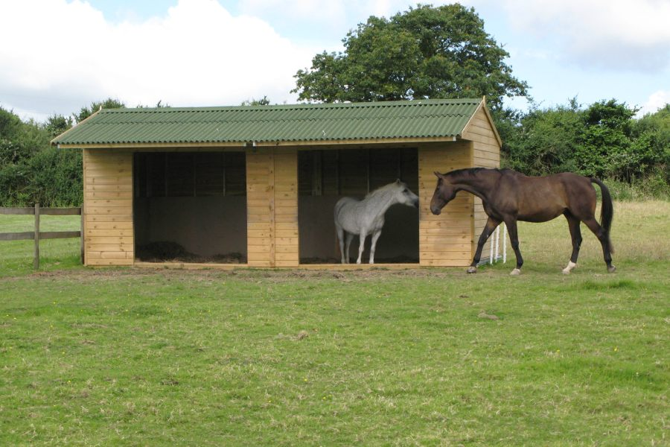
All money raised will go towards buying Field Shelters for the Rescue Ponies.
All classes will be 2 rounds. The 2nd round will be timed.
£10 per class. Entries will Close on Thursday 30th March 2023
Class 1 Lead Rein
Class 2 30 cms
Class 3 40 cms
Class 4 50 cms
Class 5 60 cms
Class 6 70 cms
Class 7 80 cms
Entries are open to all.
All entries online on F&D Hunt Branch of the Pony Club website.
Please pay for entries on https://www.fndponyclub.org.uk/bookings/

