FLINT & DENBIGH HUNT BRANCH
Of the
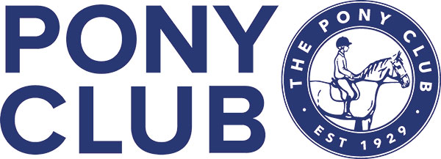

Winter League Team & Individual Dressage Competition
Sun 20th November 2022
At
The Equine Unit,
Coleg Cambria, Northop.
CH7 6AA
Entries Close Wed 16th Nov 2022
Enquiries:
Mrs Iona Pierce
01824 790327
email: secretary@fndponyclub.org.uk

Times Friday 18th Nov
Will be emailed out to all & put on Area 5 web page

FLINT & DENBIGH HUNT BRANCH OF THE PONY CLUB
Winter League Team & Individual
DRESSAGE COMPETITION
At
The Equine Unit,
Coleg Cambria, Northop.
CH7 6AA
Sun 20th November 2022
Entries Close Wed 16th November 2022
Entry Fee £16 Walk Trot £10
Dressage Tests:

Class 1 Pony Club Walk Trot Test 2022 (Incl Lead Rein)
Class 2 Pony Club Grassroots 2018
Class 3 Pony Club Novice 2020
Class 4 Pony Club Intermediate 2022
Class 5 Pony Club Open 2020

Tests may be called All trot work may be sitting or rising All horses/ponies apart from class 5 must compete in a snaffle All classes will be run according to Pony Club Area 5 Winter League Dressage rules 2022

Points will be awarded individually and for Teams as per Area 5 Winter League Dressage rules.

Members will be required to print their own numbers and use number bibs/bridle numbers.

Please email your entries & details to Iona Pierce. secretary@fndponyclub.org.uk and pay online on the F&D Branch website under Bookings.

All the Rules are available on the PCUK website.

All accidents should be reported to the show secretary for inclusion in the accident book
If any horse/pony has been in contact with strangles or any other infectious disease, it should not attend the competition. Equine Influenza/Vaccine Compliance All horses/ponies vaccination should comply with rules for PCUK.
Details can be found at https://pcuk.org/media/eibpycgm/the-ponyclub-vaccination-rule-v22-1-1.pdf
Please ensure you have your horse/pony passport with you. Refunds if cancellation of competition occurs In the event of cancellation, refunds will be made, minus any expenses/admin incurred by the hosting branch. This amount will be checked and approved by Area 5 representative before refund is made.

Health & Safety The organisers of this event have taken reasonable precautions to ensure the health and safety of everyone present.
For these measures to be effective, everyone must take all reasonable precautions to avoid and prevent accidents occurring and must obey the instructions of the organisers and all the officials and stewards.
Disclaimer of Legal Liability Save for the death or personal injury caused by the negligence of the organisers, or anyone for whom they are in law responsible, neither the organisers of this event or The Pony Club nor any agent, employee or representative of these bodies, nor the landlord or his tenant, accepts any liability for any accident, loss, damage, injury or illness to horses, owners, riders, spectators, land, cars, their contents and accessories, or any other person or property whatsoever.
Entries are only accepted on this basis.

