Pony Club Areas 4 & 5 | 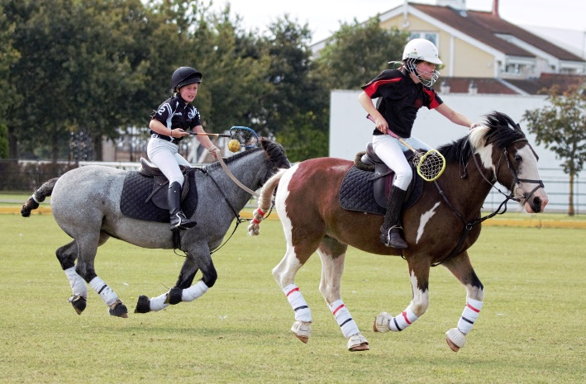
POLOCROSSE TRAINING
Monday 31st May 2021

Area 5 Polocrosse are running a polocrosse training day, 10am – 4pm, open to all PC members. The day will be split by ability, with groups for experienced players and complete beginners of all ages.

Beginner sessions are designed to introduce Pony Club members to this exciting sport, with all equipment provided and run by experienced and qualified Polocrosse coaches. The only requirement for your pony is that they be happy in close proximity to others.

This training day will be held at JF Polo Academy - Swinford Stables, Norton's Ln, Great Barrow CH3 7JZ. The cost for the full day will be £30 per player.

Important Info

- All players under the age of 18 MUST have a responsible adult on site at all times.

- This session will be on grass.

- For training sessions, experienced players and adult players must have sports boots/bandages and overreach boots on all four legs, and a breastplate. These may be borrowed if required. Beginner players may do the same but if is not mandatory for first sessions due to the slower speeds and lower levels of contact.

- All Pony Club and UK Polocrosse Association requirements will be adhered to regarding COVID-19 rules.
To book your spot on these sessions please complete the relevant booking form on the next page and return to Amy at amyandcleo@msn.com as soon as possible. Places are limited so it will be first come, first served.

For more details and/or to book please contact Amy Galvin on 07958 358522 or on the above email.

AREAS 4 & 5 POLOCROSSE TRAINING DAY
BOOKING FORM for 31 May 2021

Numbers will be limited so apply early to avoid disappointment. Payment to be made on booking via BACS, see below for details.

Name
Branch/Centre (if PC)
Contact No.
Email Address
Age
Size of Pony
Any medical conditions / allergies?
Do you need to borrow a stick?

Payment Info: Sort code: 09-01-27 / Account No: 16986710 / Name on Account: A L GALVIN
- Please make sure you include your surname and event date as a reference

