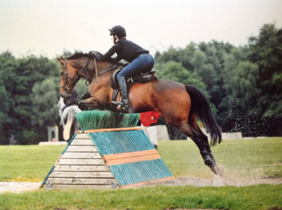

Area 5 of the Pony Club 16+ Camp 2021

Tuesday 13 – Friday 16th July 2021
at Somerford Park, Congleton

Specialised training in Flatwork, Show Jumping, Cross Country and theory with top trainers.

Evening entertainment and guest speakers.

£310 for the camp includes stabling, haylage and 2 bales of shavings, as well as food, shower facilities etc for riders.

Cheques to be made payable to “Area 5 of the Pony Club”

Applications by Sunday 13th June 2021

Organiser: Meg Green, Ty’r Aer Mawr, Bodfari
Denbigh. LL164HY.
07717413105
Let me know if you wish to pay by BACS.

Name + Branch of Rider:
Age: (as of 12.7.21)
Address:
Email:
Tel/Mob Number:
Special Requirements: eg. vegetarian
Name of Horse:
Age and Height of Horse:
Level currently training/competing:
Tests Achieved:
Area 5 of the Pony Club 16 + Camp 2021 Application Form

Please return, with payment to:

Meg Green, Ty’r Aer Mawr, Bodfari, Denbigh. LL16 4HY
07717413105

