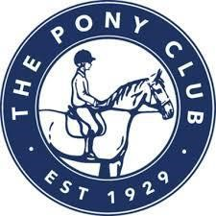
Pony Club C+ Test Training via Zoom
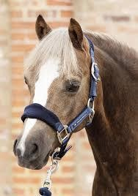
Area 10 is delighted to offer C+ training weekly online with PC
Accredited Coaches, Vicky Clark and Kate Gedge. Come and join your fellow PC friends for fun and interactive learning sessions focusing on the Care Sections of the C+ Test. You can complete the whole 6-week course or dip in and out to suit you.
Cost: £5 each per session or £30 for the full course of 6 sessions plus a £1 booking fee for Horse Events. Payment is required on booking (each session can be booked separately and there is no commitment to complete all 6 sessions).
These online lessons will take place weekly on a Thursday at 7.30pm and include 45mins teaching and 10 mins for discussion and questions afterwards.
Dates: 4 March, 11 March, 18 March, 25 March, 1 April and 8 April.
As there will be two instructors and the opportunity to split into ‘break out’ rooms to help learning and discussion.
If you are interested in taking part or would like more information please see the Session Plans below or contact Isobel Mills, Area 10 Representative via the following email: area10@pc.org.
Enter online at www.horse-events.co.uk All entries are subject to a non-refundable booking fee which will be stated online on a per class basis.

