Tanatside Hunt Branch Pony Club
EXPRESS EVENTING
OPEN TO ALL
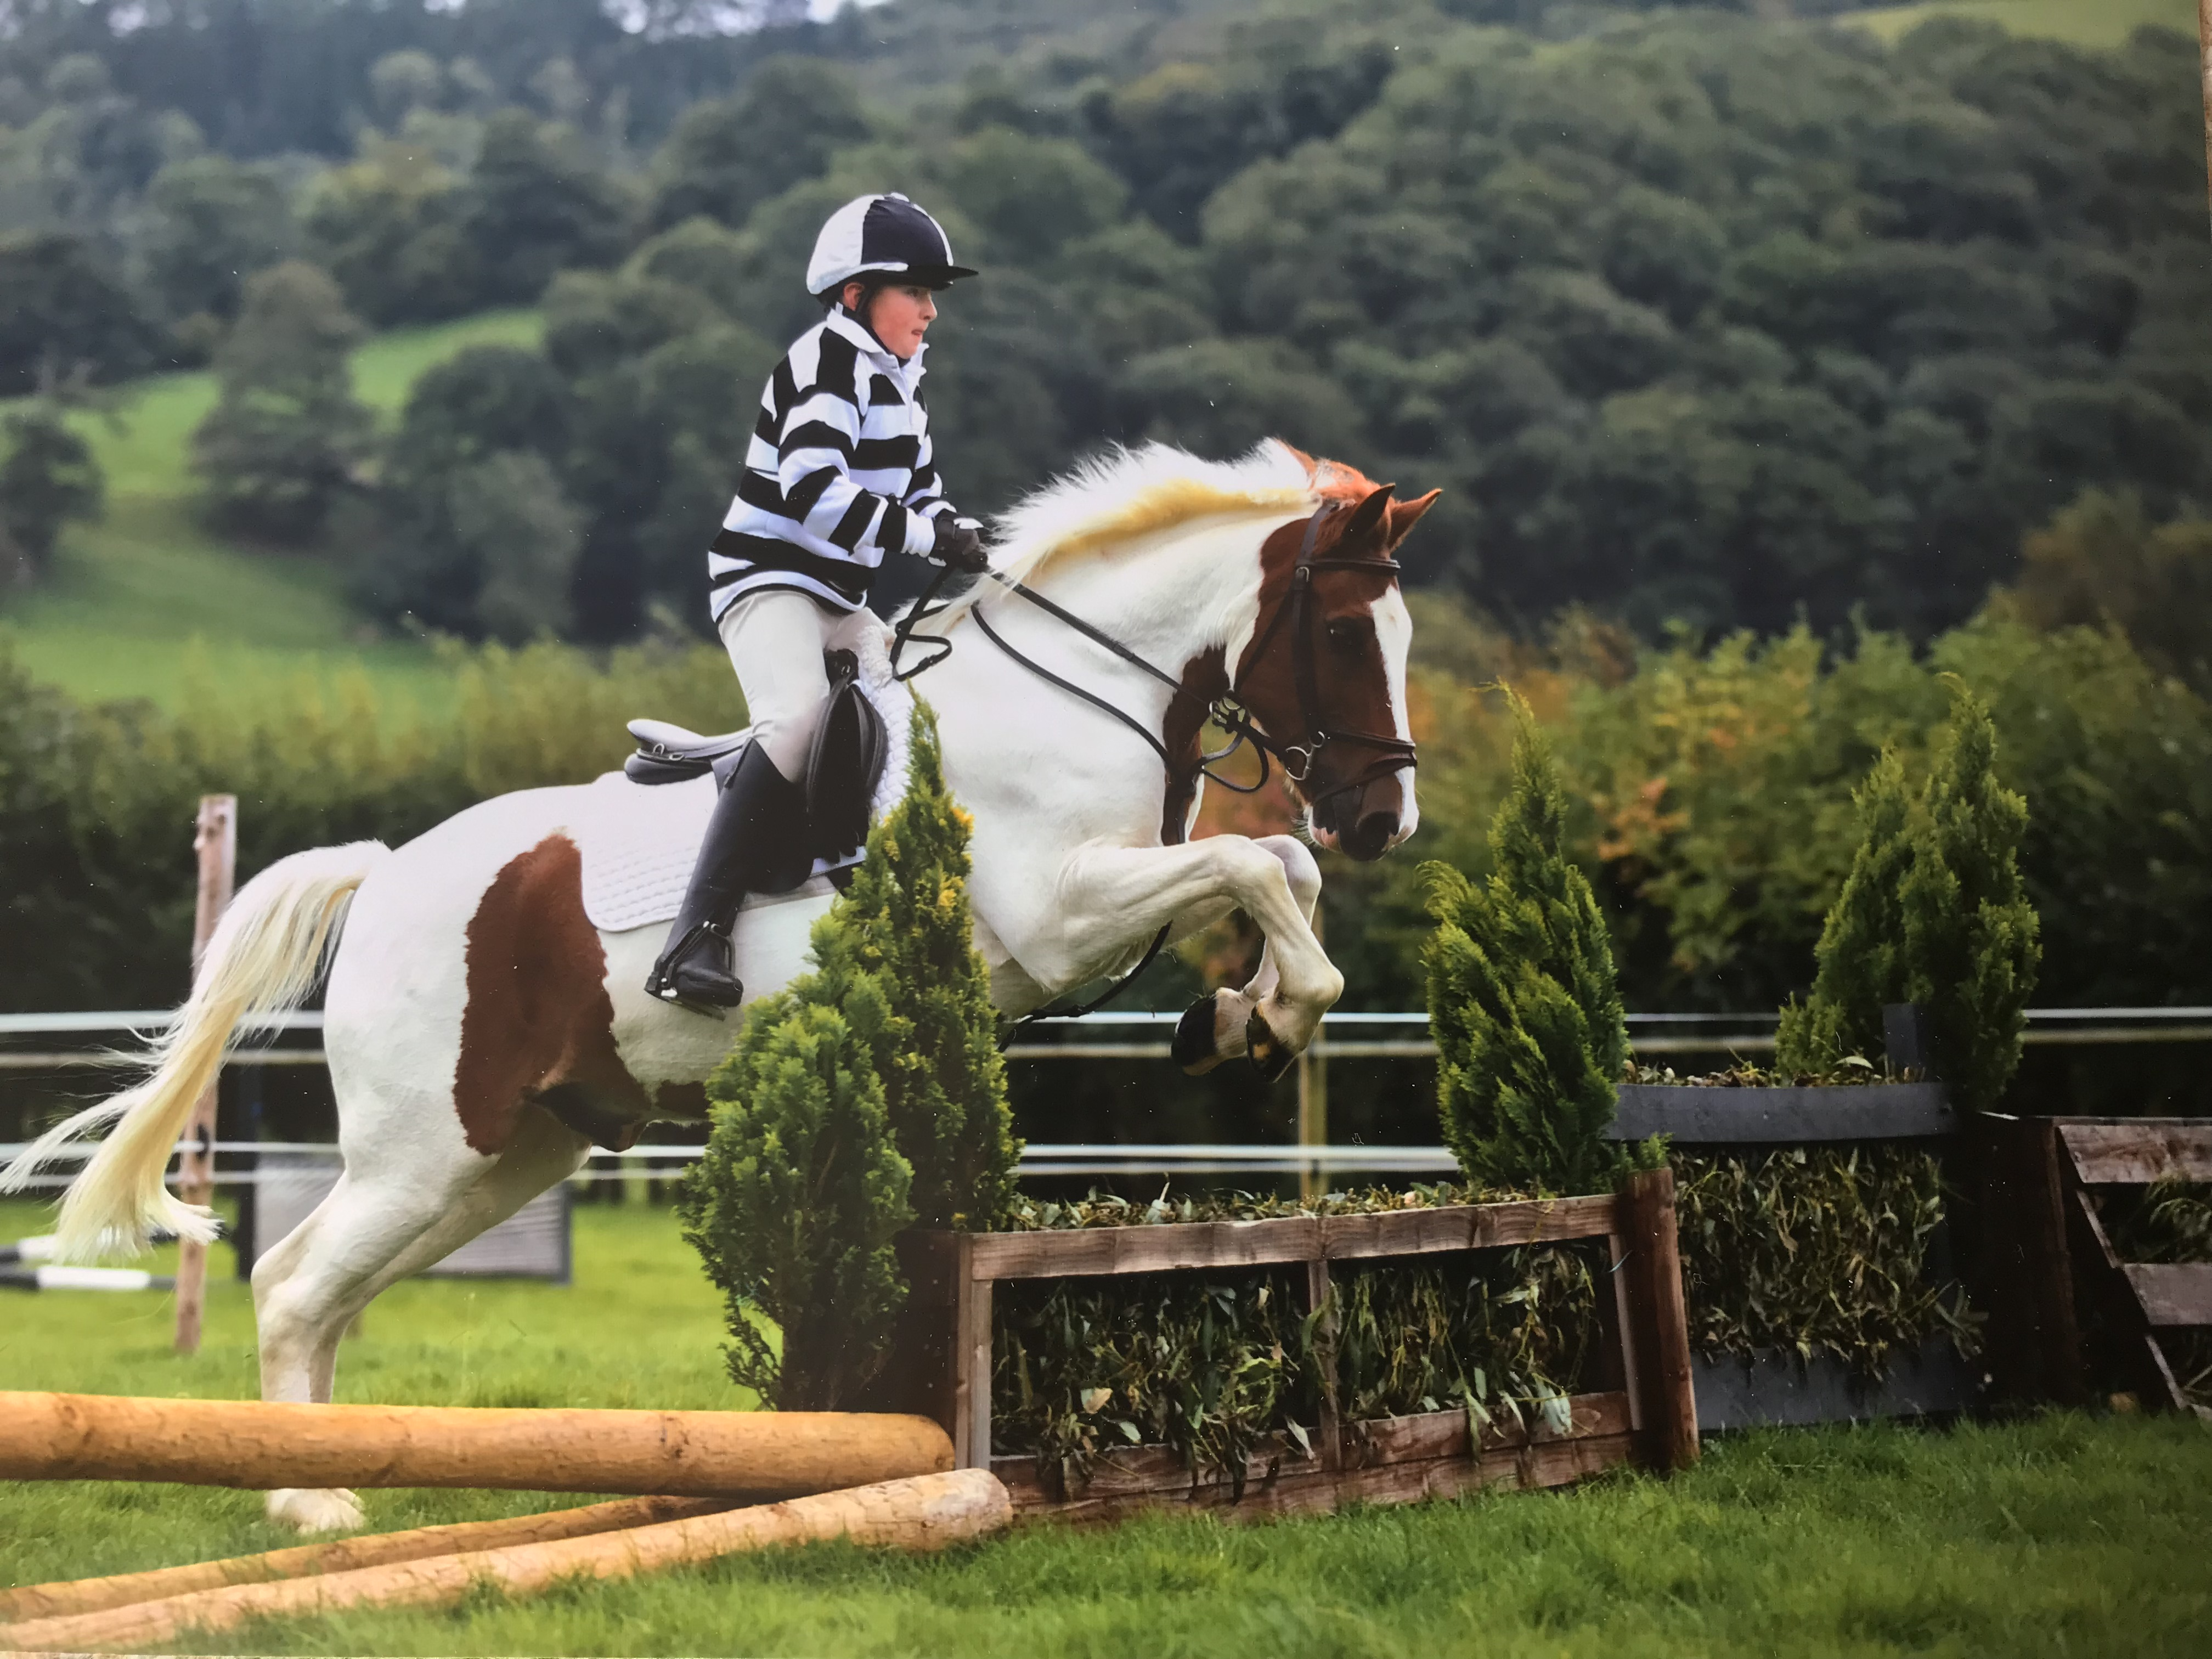
Plus, dressage only
Sunday 15th July 2018
At The White House and Dyffryn, Meifod, Powys, SY22 6DA
By kind permission of Alison Lewis Saddlery,
please follow directions on A495 to car and lorry park
May Whiston Photography, Refreshments
Express Eventing consists of a dressage test and a combined show jumping and cross-country course
We will run under 30cm ,40cm, 60cm, then finish with 80cm class
Multiple entries encouraged, to build confidence.

Rules:
- The judge’s decision is final
- No liability can be accepted by the organisers or land owners for any loss, damage, accident or illness of riders, horses, ponies, vehicles or to any persons or property whatsoever
- The show organisers reserve the right to cancel or combine classes if insufficient entries
- All hats must be to the standard required in Pony Club Health, Safety and Safeguarding Rules 2017. No fixed peaks for jumping phase.
- Body protectors must be worn for the jumping phase and must meet BETA 2009 Level 3 standard
- Riders must wear safe and suitable footwear and have long sleeves for jumping. All tack should be in good condition and safe. Pony Club members will be tack checked.
- Dressage phase: 80cm class, full PC competition rules apply, i.e.: snaffle bridle, no martingale, no boots on horse. All other classes, any bit allowed and martingales permitted.
- Please take your rubbish home
- In the event of adverse weather conditions, the organisers reserve the right to cancel the event
Disclaimer:
Save for the death or personal injury caused by the negligence of the organisers, or anyone for whom they are in law responsible, neither the organisers of this event or The Pony Club nor any agent, employee or representative of these bodies, nor the landlord or his tenant accepts any liability for any accident, loss, damage, injury or illness to horses, owners, riders, spectators, land, cars, their contents and accessories, or any other personal property whatsoever, whether caused by their negligence, breach of contract or in any other way whatsoever. Entries are only accepted on this basis.
The organisers of this event have taken all reasonable precautions to ensure the health and safety of everyone present at this event. For these measures to be effective, everyone must take all reasonable precautions to avoid and prevent accidents. They must obey the instructions of the organisers and all officials and stewards.
All none Pony Club competitors are not covered by The Pony Club insurance and must have their own third-party cover. The Tanatside Hunt Branch of The Pony Club and the organisers of this event are not legally responsible for non-members and their insurance will not cover you.
Number bibs will be used and require a £10 deposit. If you bring your own bib please ensure you have printed your own number
Privacy Notice

Tanatside Hunt Branch of the Pony Club (THBPC) is committed to protecting your personal data and processing it only in accordance with legal requirements. We process your personal data as it is necessary for the performance of our contract with you in order to facilitate your entry to the event. We will not share your data with third parties with exception that the results may be published on our website.
We retain your data in accordance with the Pony Club’s data protection policy.
You have various rights in the data we hold including rectification and objecting to processing. For further information please contact our DC.

Many thanks to all our class sponsors
Dolgead Hall Caravan & Lodge Park
Hardings Sheds & Garden Centre
Dorian Lloyd Farrier
SM Davis Transport Ltd
G-Force Steam Ltd
James Pickstock Ltd
Rhos Farm Equestrian
Maesglyn Eggs

Many thanks to all our fence sponsors
Aubrey Kirkham Funeral Directors
Balfours
Elgan Harries Farrier
K A Lewis Agri Lt
Paul Andrew
C V & E M Lewis & Sons
Kings Head Meifod
G E Stephens & Sons
Cadwallader & Co
Wynnstay
Ian Coe Farrier

Classes
Under 30 cm class SPONSORS
Section A- Lead rein / or run with rider Dolgead Hall Caravan & Lodge Park
Section B – Unassisted Hardings Sheds & Garden Centre
Dressage test: PC Walk and Trot 2013
Entry £25.00 (Tanatside members £20.00)
40 cm class
Section A- Lead rein / or run with rider Dorian Lloyd Farrier
Section B- Unassisted SM Davis Transport Ltd
Dressage test: PC Walk and Trot 2013
Entry £25.00 (Tanatside members £20.00)
60cm class
Section A- Age 12 and under G-Force Steam Ltd
Section B- Age 13 and over James Pickstock Ltd
Dressage test: Grassroots dressage test 2018
Entry £25.00 (Tanatside members £20.00)
80cm class
Section A- Age 14 and under Rhos Farm Equestrian
Section B- Age 15 and over Maesglyn Eggs
Dressage test: Grassroots dressage test 2018
Entry £25.00 (Tanatside members £20.00)
Dressage only
Dressage test: Grassroots dressage test 2018
Entry £12.00
Clear round show jumping
Entries on the day. Entry £3.00

THE PONY CLUB
WALK & TROT DRESSAGE TEST 2013
(20m x 40m Arena)

The Test |  |  | Max. Marks | Directives
1. | A X | Enter in medium walk.  Halt, salute. Proceed in medium walk. | 10 | Active walk. Straightness on the centre line and in halt.
2. | C HXF  Between H&X | Track left.  On the diagonal. Transition to working trot. | 10 | Correct rhythm in walk and trot. Active steps and transition.
3. | A  AK | Circle right 20m diameter in working trot.  Working trot. | 10 | Good shaped circle with correct rhythm and bend.
4. | Between K&E EH | Transition to medium walk. Medium walk. | 10 | Balanced transition. Correct walk rhythm and active steps.
5. | C | Halt 3-5 seconds. Proceed in medium walk. | 10 | Balanced, relaxed and still halt. Obedient transition to walk.
6. | MXK  Between M&X | On the diagonal. Transition to working trot. | 10 | Correct rhythm in walk and trot. Active steps and transition.
7. | A AF | Circle left 20m diameter. Working trot. | 10 | Good shaped active circle with correct rhythm and bend.
8. | Between F&B BMC | Transition to medium walk. Medium walk. | 10 | Balanced transition. Correct walk rhythm and active steps.
9. | HXF  FA | Change the rein on the diagonal free walk on a long rein.  Medium walk. | 10 | Activity of the walk. Stretching down of the neck. Straightness on diagonal.
10. | Between A&K E | Transition to working trot. Half circle 20m diameter to B. | 10 | Obedient, active transition. Correct rhythm and good shaped half circle.
11. | BF  Between F&A | Working trot.  Transition to medium walk. | 10 | Balanced transition. Correct rhythm in walk and trot.
12. | A G | Turn onto the centre line. Halt and salute. | 10 | Active walk. Straightness on the centre line and in halt.
Leave the arena at free walk on a long rein at A
13. |  | The paces and way of going of the pony. | 10 | Correct rhythm, balance, activity and bend.
14. |  | The use of the arena and accuracy. | 10 | Good shaped movements and riding of the corners.
15. |  | The rider’s influence and  balance. | 10 | Position of rider and ability to influence the pony.
 |  |  | 150

Approx. time 5 minutes.
To be ridden in any normal riding bit.
All trot work to be executed ‘sitting’ or ‘rising’.

© The Pony Club 2013

THE PONY CLUB

GRASSROOTS DRESSAGE TEST 2018
(20m x 40m Arena)

The Test |  |  | Max. Marks | Directives
1. | A | Enter in working trot and proceed down the centre line without halting. | 10 | Straightness of entry and regularity of trot.
2. | C | Track right. | 10 | Bend and balance on turn.
3. | ME | Change the rein. | 10 | Regularity of trot and straightness on diagonal.
4. | A | Circle left 20m in working trot. | 10 | Size and shape of circle. Balance, rhythm and suppleness.
5. | FE | Change the rein. | 10 | Regularity of trot and straightness on diagonal.
6. | C | Circle right 20m in working trot. | 10 | Size and shape of circle. Balance, rhythm and suppleness.
7. | Between C&M |  | 10 | Balance of the transition. Regularity of walk.
 |  | Medium walk.
8. | MXK | Free walk on a long rein. Just before K medium walk. | 10 | Activity of walk. Stretching down of neck, straightness on diagonal. Balance and activity of transition to medium walk.
9. | Between K&A |  | 10 | Balance and activity in transition.
 |  | Working trot.
10. | A | Circle left 20m and after crossing the centre line and before A working canter left. | 10 | Balance, rhythm and suppleness. Size and shape of circle. Balance in transition.
11. | B | Circle left 20m and on the second half of the circle working trot. | 10 | Regularity of canter. Size and shape of circle. Suppleness. Balance in transition.
12. | MCH | Working trot. | 10 | Regularity of trot.
13. | HXF | Change the rein in working trot. | 10 | Regularity, rhythm of trot and straightness on diagonal.
14. | A | Circle right 20m and after crossing the centre line and before A working canter right. | 10 | Balance, rhythm and suppleness. Size and shape of circle. Suppleness. Balance in transition.
15. | E | Circle right 20m in working canter and on the second half of the circle working trot. | 10 | Regularity of canter. Size and shape of circle. Balance in transition.
16. | HC | Working trot. | 10 | Regularity of trot.
17. | M | Medium walk. | 10 | Balance in the transition. Regularity and activity of the walk.
18. | B | Half circle 10m to X. | 10 | Regularity, balance and bend on half circle, straightness on the centre line.
19. | G | Halt. Immobility. Salute. | 10 | Straightness and relaxation in halt.
Leave the arena at free walk on a long rein at A
20. |  | Paces | 10 | Freedom and regularity.
21. |  | Impulsion | 10 | Desire to move forward, elasticity of steps, suppleness of the back and engagement of the hindquarters.
22. |  | Submission | 10 | Attention and confidence, harmony, lightness and ease of the movements, acceptance of the bridle and lightness of the forehand.
23. |  | Rider position and seat | 10 x 2 | Correctness and effect of the aids.
 |  |  | 240

Approx. time 4 1/2 minutes.
All trot work to be executed ‘sitting’ or ‘rising’. © The Pony Club 2018

TO ENTER:
Online at:
http://branches.pcuk.org/tanatside Online booking tab on left hand side
Look for Express Eventing on 15th July 2018 and book in and pay via PayPal
Post to:
Mrs Anna Pryce, Dolgead Hall, Llanfair Caereinion, Welshpool, Powys, SY21 0HT
Please make cheques payable to: Tanatside Hunt Branch Pony Club or THBPC
Entries close on Tues 10th July 2018
Times will be posted on Tanatside website by Friday 13th July 2018
Any enquiries please ring 01938 500237

Name………………………………………………………………………………………………………….
Address……………………………………………………………………………………………………….
…………………………………………………………………………………………………………………..
Contact No…………………………………………………………………………………………………..
Class:
Section :
Name of rider:
Age of rider: Name of horse/pony:

Class:
Section :
Name of rider:
Age of rider: Name of horse/pony:

Class:
Section :
Name of rider:
Age of rider: Name of horse/pony:

