Flint & Denbigh Hunt Supporters Pootle and Scootle

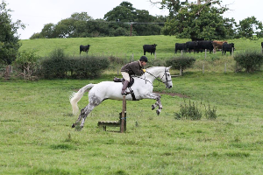

Sun 17th September at Gwysaney Hall
Mold, CH7 6PA.
follow signs from the A541 Mold Denbigh Road

A true hunting experience without hounds & optional jumps
Experience the thrill of crossing some fabulous countryside on the Gwysaney Estate.
PLEASE NOTE: All jumps are optional and it is open to all. If your horse is comfortable cantering in a group then why not come and give it a go. There will be a Jumping and Non Jumping Field Master who will be there to help you enjoy your afternoon.
We meet and have a stirrup cup before moving off around 12.30pm. We will then proceed at a steady pace for about 45 minutes with optional jumps along the way. You can then enjoy a midway break for about 20 minutes for some refreshments, before continuing for a further 45 minutes where we will finish at the lorry park. You can then enjoy a well-earned burger from the BBQ on your return.

Please note there is no official dress code

Price Adults £20, Under 16s £15, Pony Club Members £10

