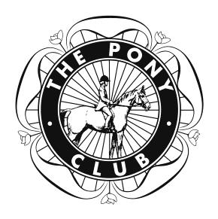
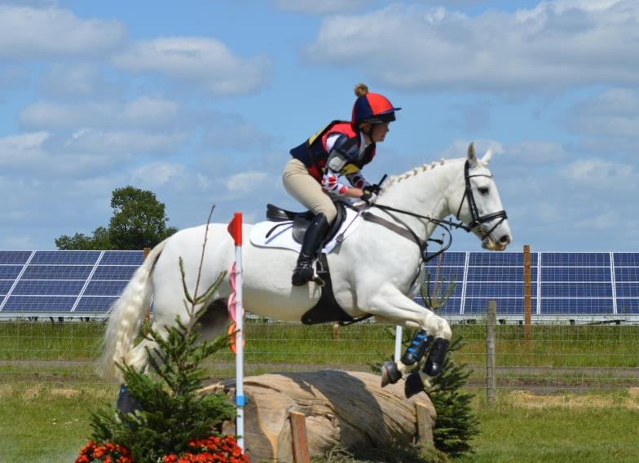
South Shropshire Hunt Branch of the Pony Club ONE DAY EVENT 70, 80 & 90 classes

Sunday 9th July 2017 BERRIEWOOD FARM, CONDOVER, SHREWSBURY, SY5 7NN.
Entries Secretary

Bethan Owen
Email: southshropshireentries@outlook.com Phone : 01691 682 666 or 07971 466 098 Address : 22 Coly Anchor
Kinnerley, Oswestry, Shropshire. SY10 8 BY

ENTRIES BY EQUO (Preferred method) or by post with cheque to SSHBPC

Joint Organisers

Mr S Hemming & Mrs K Varley Opening Date – 8th April 2017
Closing Date – Monday 3rd July 2017
Late entries will be accepted if there is room – £10 surcharge
Times – Thursday 6th July 2017 7pm-9pm on 07971 466098 or 01691 682 666 www.pcuk.org/southshropshire or

www.berriewood.co.uk

Cross Country course will be available to walk between 2pm - 8pm on Saturday 8th July 2017

Class 1

Dressage: Show Jumping: Cross Country:

Class 2

Dressage: Show Jumping: Cross Country:

Class 3

Dressage: Show Jumping: Cross Country:
70 cm – (Open to All)

Pony Club Grassroots Dressage Test 2016 75cm
70cm

80 cm – (Open To All)

Pony Club 90 Eventing Test 2013 85cm
80cm to be run over an amended BE 80 Level Training Course

90 cm – (Open To All)

Pony Club 90 Eventing Test 2013 95cm
90cm to be run over an amended BE 90 Level Training Course

Classes will be divided into sections according to entries Dressage Tests are available on Pony Club Website

Entry Fee: £45 (£35 SSHPC)*. There is a £5 First Aid Fee to be paid on the day at the secretary. All entries must be accompanied by the correct entry fee. Proof of insurance or membership must be sent with entry or emailed as described below – you will not be able to compete unless we have this.
Preferred method of entry is via Equo. If entering by post, cheques should be made payable to SSHBPC. Please put the name of horse and class number on the back of cheque.
*[if entered via Equo, this includes the Equo booking fee]

Proof of insurance – to be emailed in advance to Bethan Owen (email address above) - All Pony Club entries need proof of membership by DC or Branch Secretary - All other entries must provide membership number or copy of insurance

Please familiarise yourself with the 2017 Rule Book. By entering this competition you are confirming that you have read and agreed to the rules and regulations.

Please provide your own number bib, however, there will be a few number bibs available to hire with a £10 deposit.

Refunds and Cancellation
A full refund will be given to anyone needing to withdraw before the closing date (Monday 3rd July – at 12 noon) providing it is received in writing - Email (preferably) or post (letter must be received before 12 noon on 3rd July)
There will be no refunds for withdrawals received after 12 noon on 3rd July, however the horse/rider may be substituted provided the secretary is informed in writing. The DC may agree to a refund in exceptional circumstances.
Cancellation of event – Before Friday 7th July at 8 am a full refund will be made for each entry. If the event has to be cancelled after 8 am on Friday 7th July when £5 will be retained to help defray costs incurred.

Rosettes and Awards Rosettes to 8th place in each Section
Special rosette for highest placed rider 12 years and under in each section on 1st Jan 2017. Rosettes in each section for the highest dressage score completing all three phases. Award to the winner of each section.
Award to highest placed South Shropshire PC member in each section.
Rosette to highest placed SDRC member in each section.
Awards will be made at the end of each class at the Secretary’s Marquee. Prize Winners must attend prize giving correctly dressed.

PHOTOGRAPHER & REFRESHMENTS WILL BE AVAILABLE ON SITE.

CONDITIONS OF ENTRY

1. The competition will be run in accordance with the Pony Club Rules 2017. 2. There will be a £5 First Aid Fee towards medical cover – non refundable.
3. Hats for all phases must be to current Pony Club standard. They will be checked when you collect your numbers from the Secretaries. There will be a tack check at all phases.
4. Body protectors and medical armbands must be worn by all competitors for the cross country phase. Anyone using an Expo protector must inform the Secretary as per the rule book.
5. It is a Pony Club rule that Pony Club Members wishing to wear spurs must have a letter from their DC. (or Email DC in advance) Holders of B and A (Riding) Tests are exempt from this rule.
6. Competitors from visiting branches, entering electronically, must forward an email from their DC or Branch Secretary confirming their membership, or arrange for such an email to be sent direct to the Entries Secretary. This email must be received before the Closing Date.
7. Non-Pony Club, Riding Club and BE Members must send photocopied proof of their own insurance (3rd party legal liability) before the Closing Date.
8. No horse/pony may compete in more than one class and must be 5yrs old or over.
9. Dressage sheets will not be given out until after the results have been announced. A SAE may be left with the secretary for sheets to be posted to competitors.
10. Competitors and spectators attend at their own risk.
Save for the death or personal injury caused by the negligence of the organisers, or anyone for whom they are in law responsible, neither the organisers of this event or The Pony Club nor any agent, employee or representative of these bodies, nor the landlord or his tenant, accepts any liability for any accident, loss, damage, injury or illness to horses, owners, riders, spectators, land, cars, their contents and accessories, or any other personal property whatsoever, whether caused by their negligence, breach of contract or in any other way whatsoever. Entries are only accepted on this basis.
The organisers of this event have taken all reasonable precautions to ensure the health and safety of everyone present at this event. For these measures to be effective, everyone must take all reasonable precautions to avoid and prevent accidents. They must obey the instructions of the organisers and all officials and stewards.
All non-Pony Club competitors are not covered by The Pony Club insurance and must have their own third party cover. The South Shropshire Hunt Branch of The Pony Club and the organisers of this event are not legally responsible for non-Members and their insurance will not cover you.

11. Any inappropriate behaviour towards horse/pony, fellow competitors or officials can lead to elimination.

Entry Form for Postal Entries only

CLASS | RIDER | Age if under 18yrs | PONY/HORSE | PONY CLUB/ RIDING CLUB | Fee
Please print clearly on a separate piece of paper some brief details about your horse and yourself for the cross country commentator. |  |  | Total amount

Entry Fee: £45 (£35 SSHPC). A £5 First Aid fee will be charged in addition to this – paid on the day.
All entries must be accompanied by the correct entry fee & proof of insurance or membership. Cheques should be made payable to SSHBPC. Please put the name of horse and class number on the back of cheque.

Address:

Telephone Number:

Email Address:

DC Signature:

Riding Club Membership/British Eventing No:

Your signature – or Parent signature if competitor is under 18yrs. (confirming you have read, understood and agree to comply with our rules & conditions):

Signature …………………………………………………………………………Date……………………..

