**RULES**

The committee or land owners cannot be held responsible for any damage, loss or injury to persons, horses or property.

The decision of the committee and judges will be final.

The committee reserves the right to cancel any classes if insufficient number of entries.

Any persons competing or otherwise, when mounted, must wear protective headgear with the harness properly adjusted and fastened at all times

Riders must be in PC or competition dress and conduct themselves appropriately. Age is taken as on 1st Jan 2012.

This competition is open to Pony Club members, Riding Club members and non-members.

Classes will be split into Juniors (16 and under) and Seniors.

Pony Club members must hold a valid spur card.

Aggressive behaviour, foul language, excessive use of spurs or whips by riders, handlers and/or spectators WILL NOT be allowed and offenders will be asked to leave the event.

All horse and ponies must be over four years old.

All dogs must be kept on leads at all times.

Please DO NOT leave litter or muck out trailers or lorries on the parking area.

No refunds will be given except for cancellation of classes or the competition.

**ABERCONWY**

**BRANCH OF THE PONY CLUB**

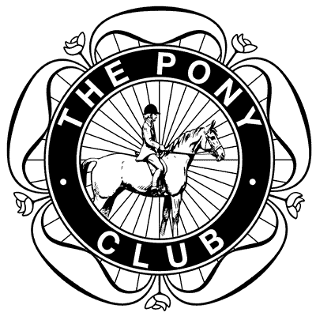 **AND**

# **LLANDUDNO & DISRICT RIDING CLUB**

Saturday September 22, 2012

**COMBINED TRAINING COMPETITION**

Queens Meadow, Llanrwst

(opposite Meadowsweet Hotel)

LL26 0DS

09.00am START

**ROSETTES TO SIXTH PLACE IN ALL CLASSES**

ENTRIES IN ADVANCE

DRESSAGE & SHOW JUMPING £15

(APC & LLDRC £12)

DRESSAGE ONLY £10

(APC & LLDRC £8)

**TESTS AVAILABLE ON BRITISH DRESSAGE WEBSITE**

**FOR MORE DETAILS PLEASE CONTACT:**

**Jenny Williams 07584 252643**

**jwilliams89@btinternet.com**

DRESSAGE TIMES WILL BE PUBLISHED ON ABOVE WEBSITES

FROM WEDNESDAY EVENING SEPTEMBER 19, 2012

**REFRESHMENTS AVAILABLE ON DAY**

COMBINED TRAINING COMPETITION

**DRESSAGE AND SHOW JUMPING**

CLASS 1 ASSISTED (LIMITED ENTRIES)

DRESSAGE: Introductory B (2009) Walk and Trot Test

SHOW JUMPS: Max height 45cms

**RIDERS UNDER 10 YEARS * LEAD REINS PERMITTED**

CLASS 2 NEWCOMERS

DRESSAGE: Introductory B (2009) Walk and Trot Test

SHOW JUMPS: Max height 60cms

CLASS 3 PRELIMINARY

DRESSAGE: Preliminary 13 (2006) Test

SHOW JUMPS: Max height 75cms

CLASS 4 NOVICE

DRESSAGE: Novice 24 (2010) Test

SHOW JUMPS: Max height 90cms

TESTS MAY BE CALLED IN ALL CLASSES

CLASSES WILL BE SPLIT INTO JUNIORS AND SENIORS

**ENTRY FORM**

|  |  |  |  |  |
| --- | --- | --- | --- | --- |
| **CLASS NO.** | **RIDER NAME & BRANCH/CLUB** | **HORSE/PONY NAME** | **AGE**  **(at Jan 1)** | **ENTRY FEE** |
|  |  |  |  |  |
|  |  |  |  |  |
|  |  |  |  |  |
|  |  |  |  |  |
| **TOTAL: £** | | | | |
| **PC ONLY: DC OR BRANCH SECRETARY SIGNATURE**  **RIDING CLUB ONLY: MEMBERSHIP No.** | | | | |

**CLOSING DATE: SEPTEMBER 12**

**PLEASE POST ENTRIES AND PAYMENT TO:**

THE BRANCH SECRETARY: **SANDIE MONKS**

**HAULFRYN, LLANDDOGED, CONWY**

**NORTH WALES LL26 0BZ**

**(07780 335231)**

CHEQUES SHOULD BE MADE PAYABLE TO:

**ABERCONWY PONY CLUB**

**CONTACT DETAILS IN CASE OF QUERY OR CANCELLATION**

NAME

ADDRESS

CONTACT NUMBER

E-MAIL