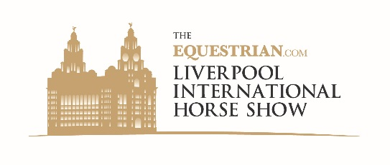
The Equestrian.com Liverpool International Horse Show 31 Dec 16 – 2 Jan 17

World class sport and spectacular entertainment from just £19.50 for adults,
£10 for children and family tickets from £49.48

We are proud to announce the second Equestrian.com Liverpool International Horse Show following the hugely successful and popular Year 1 show. It’s going to be a fantastic 4* show jumping and entertainment spectacular at the Echo Arena in Liverpool 31 Dec 16 – 2 Jan 17. Some of the world’s top names will be competing for a prize fund of €220,000 with exciting acts between classes.

A high-energy, family friendly show to make your New Year

Each day there will be afternoon and evening performances with international show jumping with entertainment for all the family. And, on the evening of New Year’s Eve a special show featuring fireworks and operatic boy band Collabro.

- Award winning Abba tribute band Revival
- Horse Power – LED dressage to music with Charlie and Abi Hutton
- The Shetland Pony Grand National – the ever popular action packed steeplechase
- Chariots of Fire – high speed carriage racing
- The Black Fire Girls – dazzling display with special effects
- To book call 0844 8000 400 or visit liverpoolhorseshow.com

Shopping Villages, Bistro and Champagne Bar

Visit the Shopping Villages with 100 outlets, enjoy gastropub style food in the Collecting Ring Bistro or Mersey View Restaurant. Treat yourself to a Champagne Bar Experience – in 2 great locations. Make a day of it – tickets give access to the venue from 9.00am for shopping and dining. With a seating capacity of 6,000 per performance, easy access by road and rail and masses of parking the Equestrian.com Liverpool International Horse Show will be the place to be this New Year!

Make it extra special in Hospitality
A spectacular ringside experience or private box, the choice is yours, with unrivalled views, fine dining and champagne reception from £195; for hospitality call 01829 307676 or e-mail melanie@bolesworth.com

Group Discounts
There’s a special 20% discount for Bronze and Silver Adult Tickets for 15 or more, call the special group booking line on 0844 561 7672.
Use the Handy Booking Form to get a group together!
20% off for Groups of 15+

Yours sincerely
Howard Blythe
Show Office

P.S. remember tickets make a wonderful Christmas gift too!
N.B. booking and administration fees apply to ticket prices.

Bolesworth Events LLP, Bolesworth Lake Farm, Chester, CH3 9HL Tel: 01829 307676

The Equestrian.com Liverpool International Horse Show 31 Dec 16 – 2 Jan 17

 | Name | Ticket Type  Bronze/Silver | Price*
1
2
3
4
5
6
7
8
9
10
11
12
13
14
15
16
17
18
19
20

- Afternoon and evening performances on each day
- All tickets give access from 9.00am to enjoy morning amateur classes, shopping and dining
- 20% discount when 15 book tickets, with super low prices on children’s tickets
- Call the Box Office* to check availability, discounted ticket prices and reservations on 0844 561 7672

