Novice, Intermediate & Open Pony Club Dengie Winter League Dressage Preliminary Round Competition
East Cheshire Pony Club
Sat 29 October 2016 – start 9.30am

Somerford Park Farm – Ash Arenas (2 arenas)
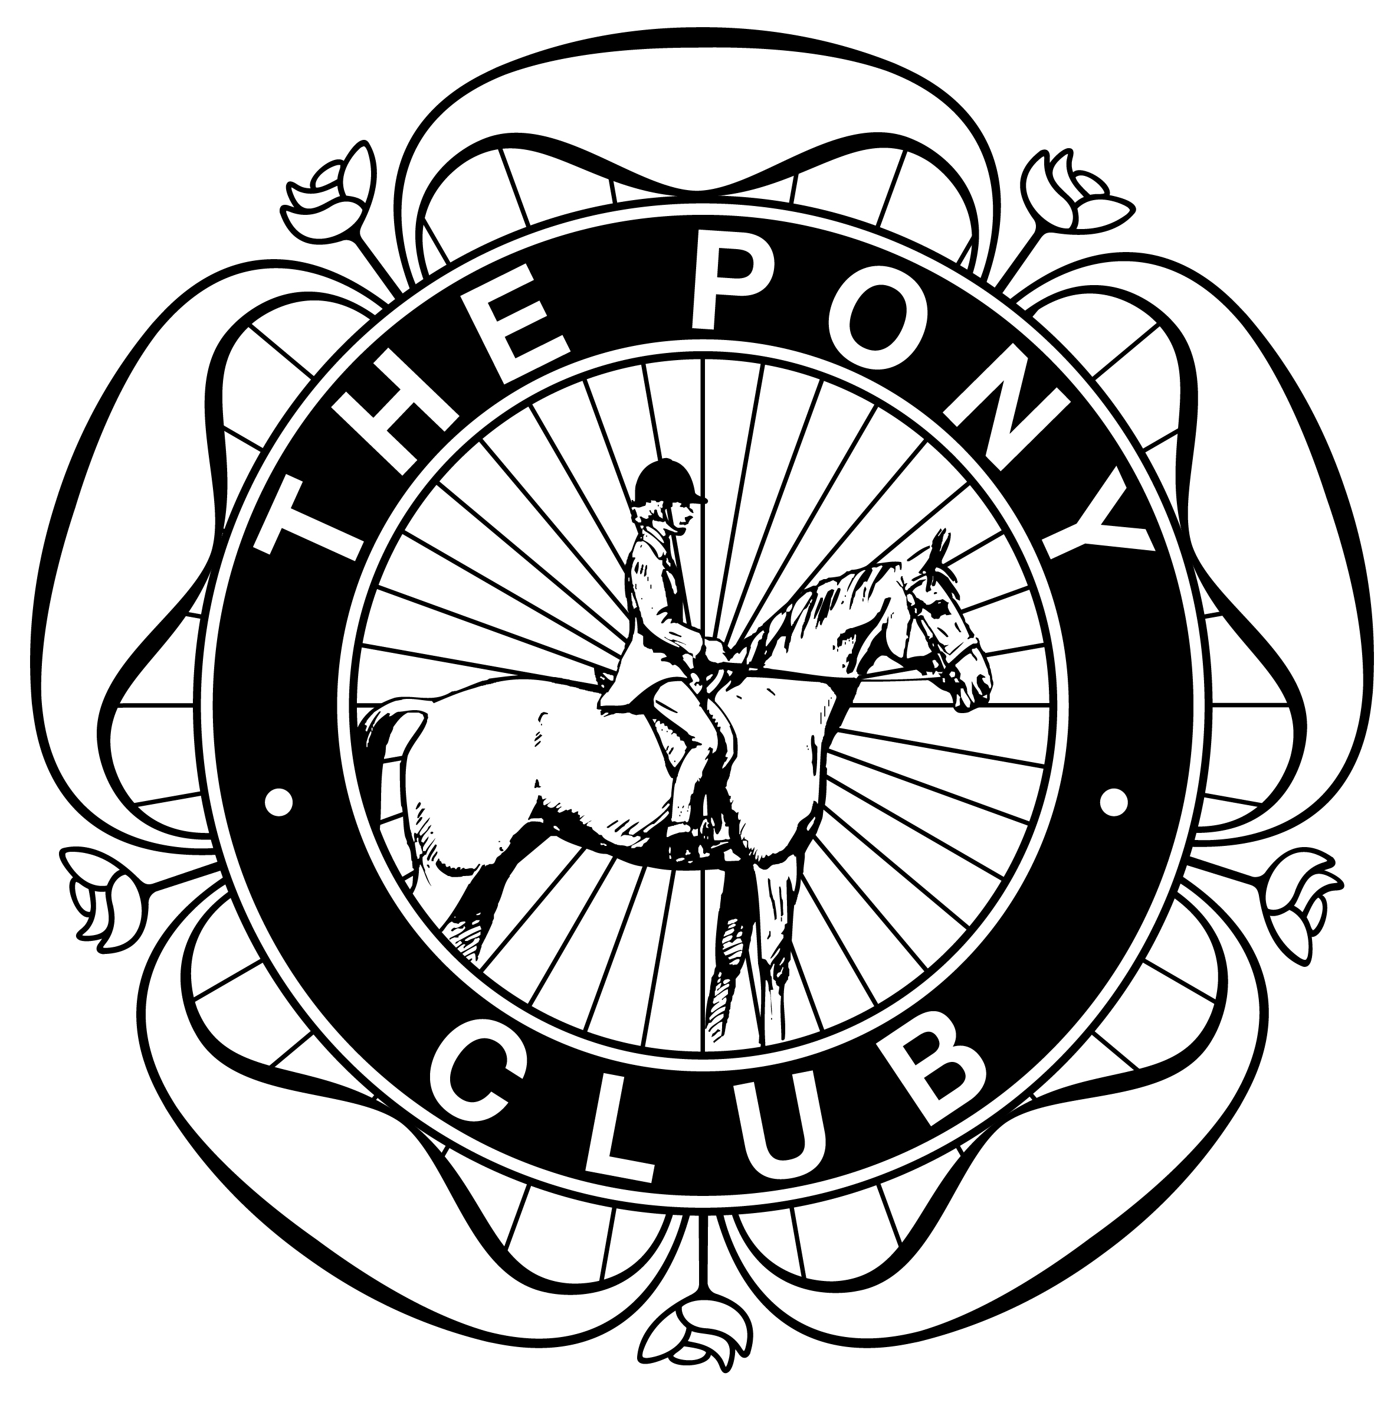
Novice Dengie Qualifier (Pony Club Novice Dressage Test 2009)
Intermediate Dengie Qualifier (Pony Club Intermediate Test 2013)
Open Dengie Qualifier (Pony Club Open Dressage Test 2015)

Entries on this form to Corrie McLellan, Cheerbrook House, Newcastle Road, Nantwich, CW5 7EL. Entry £15 per class
Closing date Friday, 21 October 2016. Times displayed on ECBPC website from Thursday evening, 27 October.
Cheques payable to “ECBPC” or enter on East Cheshire Entrymaster.
Name, Address & postcode, Tel number & mobile:-

Class | Name of rider | Age of rider  as of 1 Jan | Name of horse | Branch | Entry fee  £15 per class
Total entry fees enclosed:
Cheques payable to ECBPC or entries via entry master
http://entrymasterlite.co.uk/index.php?alias=eastcheshirepc

Rules – Dengie Dressage Winter League Rules 2016/17 apply

http://www.pcuk.org/uploads/dressage/WLDR_Rulebook_1617.pdf

