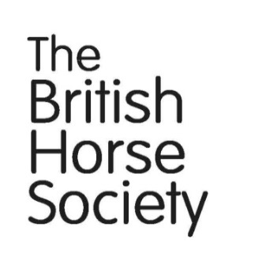
BHS North East Wales
Lecture / Demo
The Value of Lateral Work
Patrick Print OBE FBHS
Saturday 10 September 2016 7pm
Pennant Park Riding Centre
Whitford Holywell CH8 9ER
Cost £5 per person Refreshments available to purchase
Patrick will also be teaching a clinic at Pennant Park the following day. He offers sound classical training for all levels of rider from novice to advanced whether for leisure, competition or exam preparation.

Patrick became a Fellow of the BHS in 1995 and was Chairman of the British Horse Society until June 2010. Patrick is a freelance instructor, BHS Chief Examiner and Riding Clubs Master Judge. He teaches all over Britain and has examined for the Society all over the world. In 2011 he was given an OBE for services to equestrianism.

Don’t miss this unique opportunity to see and learn with one of the leading BHS Instructors in the UK!
For further information please contact:
Carl Crofts on 01352 714986 e: enquiries@pennantparkridingcentre.com
Jo Hughes on 01745 608762 e: sregor54@hotmail.com
Patrick Print Clinic
Sunday 11 September
Pennant Park Riding Centre Holywell

Group Lessons of four (1 hour) are available at £20.00 per person.
Limited places for a 2 person lesson of one hour are available at £35 per person and also a 45 minute private lesson at £50.
Places on these lessons are limited. Preference will be given to BHS members!
To apply:-
Please send your cheque – payable to ‘BHS North East Wales Region’ to
Carl Crofts, Pennant Park Riding Centre, Llwyn Ifor Lane, Whitford, Holywell. CH8 9ER
Please include a brief outline of you and your horse and what level you are working at so we can place you in a similar group.

Applicant’sName: ……………………………………………………………….………………………….
Address: ……………………………………………………….…………………… ..
…………………………………………………Postcode: …………………………...
Tel:………………………………………..Mobile: …………………….……………..
Email:……………………………………………………………………………………
BHS Number (if applicable): ………………….……………………………………..
Lesson preferred (4 Group/2 person or private) …………………………………………………………………………………………...
Prefer morning slot / Prefer afternoon slot – please state and we will try to accommodate your request if possible.
……………………………………………………………………………………………………………………………………………………………………………………

Neither BHS NE Wales. Pennant Park RC, Patrick Print nor any of their assistants shall be in any way responsible for any loss, injury or damage that may happen to participants or other members of the public, or to any animal or property or to any vehicle brought into the training ground or leaving same. NO refunds will be made if you cancel unless we can fill your space, in which case your fee less £5 admin fee will be refunded.

I hereby agree to abide by the above conditions and confirm that I am fit and well to undertake training and have had no recent fall/injury that will inhibit my riding.

Signed: …………………………………………………Date:………………………

