Pony Club Polocrosse Camp
16th – 17th August 2016
Rake Lane, Backford, Cheshire

Celyn Polocrosse Club are hosting a pre-PC Championships training camp at their Cheshire grounds close to Cholmondeley Castle. This event is open to all Pony Club members, with the aim of preparing teams and individuals for the Pony Club Polocrosse Championships.

Training will be carried out by UKCC and PC coaches. Tack checks will be carried out at the start of the camp to ensure that everyone has the correct attire for the Championships.

There will be toilets and horse water on site, but no showers. However, showers will be available once you arrive at the Cholmondeley site on Thursday.

Overnight accommodation is on site with horses in your own electric pens. First Aider cover will be on site. Racquets may be borrowed from the club.

Training will take place on Tuesday and Wednesday, before we move over to the Championships at Cholmondeley on Thursday morning.

We will also be running a UKPA section for parents/siblings of PC players. Please contact Anna Tarbuck (anna@celynpolocrosse.co.uk ) if you would be interested in taking part as a UKPA member.

Timetable:
Monday: 5pm – Campsite open for campers
Tuesday: Training
Wednesday: Training
Thursday: All playing at PC Champs move over to Cholmondeley
Friday-Saturday: PC Championships!

There will also be instruction on how to Field Marshal and goal judge for parents etc. if required.

Cost is £60 for the full camp or £35 per day, which includes all meals (all day Tues and Wed plus breakfast on Thurs). Extra meal tickets are available for parents, supporters etc. at £10 per day. Please make sure you include these on your booking form!

Payment can be made by cheque with the booking form (made payable to ‘Celyn Polox’ )or by BACS to account 02265078 Sort Code 30-97-62

For further information please see our website at www.celynpolocrosse.co.uk or contact Anna Kimber Tarbuck on 07713 443997 or anna@celynpolocrosse.co.uk .

For additional directions to the site please see the ‘find us’ section of the Celyn website.
We are situated on Rake Lane, Backford, Chester. The best postcode is CH2 4DF, but continue on past this point to arrive at the field. There will be signs on the road.

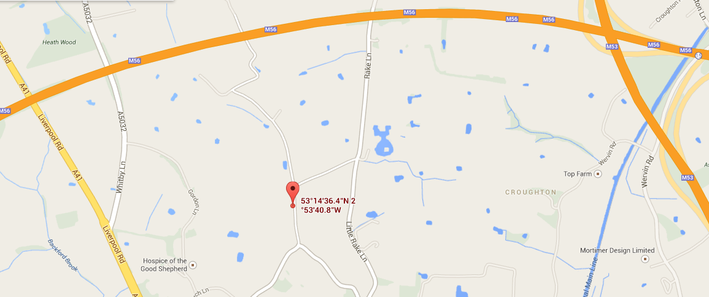

PONY CLUB POLOCROSSE CAMP BOOKING FORM

To book please complete the following information and return to Anna Tarbuck at anna@celynpolocrosse.co.uk by Wednesday 10th August 2016.

Numbers will be limited so apply early to avoid disappointment.

Name
Branch/Centre/Club
UKPA grading or skill level
Class entered at PC Champs
Contact No.
E-Mail Address
Age (if under 16)
Size of Pony (if under 16)
I wish to arrive on Monday | Yes/No Please give approx. time of arrival:
Days Attending | (delete as appropriate) All/ Tuesday/ Wednesday
Extra meals required | ……. Extra meal tickets @£10 per day (please state day(s): ……………………)
Any medical conditions / allergies?
Any dietary requirements?
Do you need to borrow a stick?
Method of Payment | (delete as appropriate) BACS / cheque

Payment may be made by cheque with the booking form, made payable to ‘Celyn Polocrosse’ , or by BACS to account 02265078 Sort Code 30-97-62 with the reference PC CAMP.

Please note that all under-18s MUST have a designated supervising adult on site at all times.

CELYN POLOCROSSE – PLAYER DETAILS

Section A (not required for Celyn Players)

PLAYER NAME: ..…………………………………………………………………………………

AGE (as at 1st Jan): ……………………………… Today’s Date: …………………………….

Any Medical conditions which may affect you while playing or practising polocrosse on foot or on horseback?

………………………………………………………………………………………………………..

………………………………………………………………………………………………………..

………………………………………………………………………………………………………..

RISK STATEMENT

Polocrosse is classed as a RISK SPORT such that there remains a risk of serious injury while playing the sport. Injuries may occur while you are practising or competing both on horseback and on foot.

All persons taking part in, or as spectators of, Celyn/UKPA activities do so at their own risk.

The UKPA and Celyn club, their officers and agents accept no liability for loss, damage or injury to persons, animals or property other than that required by statutory legislation.

By signing below (or signing on behalf of a junior) you are accepting the above Risk Statement for yourself and/or the player

Signed: ………………………………………. Print Name:……………………………………….

Section B – For all Players Under the Age of 18 years on the Day (for all as applicable)

If the player is not to be accompanied by their parent/guardian then please declare here the adult designated with on-site responsibility:

…………………………………………………………. …………………………………………….

Signed: ………………………………………. Print Name:……………………………………….

