Horse Weighing Clinic
At For Farmers
Colomendy Ind Estate
Denbigh LL16 5TA
9.30am -12noon Saturday 20th of February.
Bring your horse/pony to be weighed and receive practical feeding advice under the watchful eye of our Equine Nutritionist.
Feed offers on the day.
No advanced booking needed.
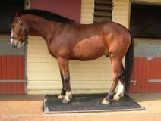
For more information please ring 01745 818310

