Novice, Intermediate & Open Pony Club Dengie Winter League Dressage Preliminary Round Competition
East Cheshire Branch of the Pony Club
Saturday 6 February 2016 – start 9.30am

Alsager Equestrian Centre
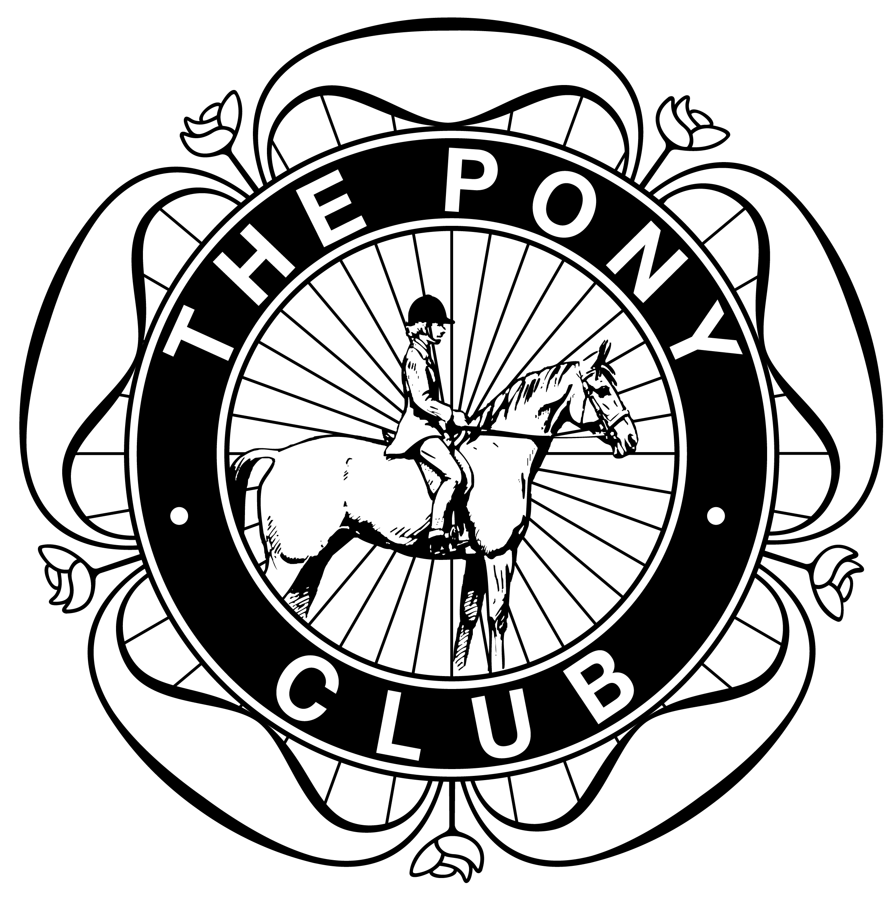
Novice Dengie Qualifier (Pony Club Novice Dressage Test 2009)
Intermediate Dengie Qualifier (Pony Club Intermediate Test 2013)
Open Dengie Qualifier (Pony Club Intermediate Dressage Test 2015)

Entries on this form to Corrie McLellan, Cheerbrook House, Newcastle Road, Nantwich, CW5 7EL. Entry £15 per class
Closing date Tuesday 2 Feb 2016. Times displayed on ECBPC website from Thurs evening prior. Cheques payable to “ECBPC”
Or please enter via our Entrymaster system: http://entrymasterlite.co.uk/index.php?alias=eastcheshirepc

Name, Address & postcode, Tel number & mobile:-

Class | Name of rider | Age of rider  as of 1 Jan | Name of horse | Branch | Entry fee  £15 per class
Total entry fees enclosed:
Cheques payable to ECBPC

No signature of visiting Branch DC’s are necessary, as non-pc members are allowed to compete at Preliminary rounds.

Rules – Dengie Dressage Winter League Rules 2015/16 apply.

