ABERCONWY
BRANCH OF THE PONY CLUB

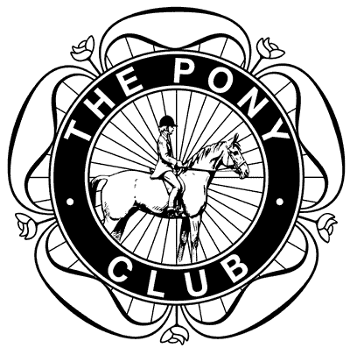
WINTER LEAGUE
SHOW JUMPING COMPETITION
Winter League Team & Individual Jumping Competition

Sunday January 17, 2016

Maelor Equestrian Centre, Hope LL12 9SD
09.00am START (Course Walk 8:30am)

ROSETTES TO SIXTH PLACE – MEDALS TO THIRD PLACE

CLASSES
CLASS 1 JUNIORS rider 10 years and under
JUMPS: Max height 2’.3” first round

CLASS 2 NOVICE rider 13 years and under
JUMPS: Max height 2’.6” first round

CLASS 3 INTERMEDIATE rider any age
JUMPS: Max height 2’.9” first round

CLASS 4 OPEN rider any age
JUMPS: Max height 3’.3” first round

ALL CLASSES £12 PER COMPETITOR
CLOSING DATE: JANUARY 12, 2016

REFRESHMENTS AVAILABLE ON DAY

RULES
Age is taken at 1 January 2015

All classes will be run over two rounds. In the 2nd round riders will compete in number order, not team by team.

Classes are restricted to ten teams.

Individual entries may be placed in a mixed team.

No competitor may ride more than one horse/pony in each team.

No pony may enter more than once.

Riders must do their Winter League round before riding any additional pony.

Hats must be worn at all times when mounted.

The judge’s decision is final.

Points will be awarded in accordance with the Winter League Rules.

HEALTH, SAFETY & WELFARE: The Organisers of this Event have taken/will take reasonable precautions to ensure the Health & Safety of every person present. For these measures to be effective, everyone must take reasonable precautions to avoid and prevent accidents occurring and must obey the instructions of the Organisers, all Officials and Stewards. First Aid cover will be provided.

DISCLAIMER OF LIABILITY: Save for death or personal injury caused by negligence of the organisers to anyone for whom they are in law responsible, neither the organisers of this event of the Pony Club, or the agent, employee or representative of those bodies accept any liability for any accident, loss, damage, injury or illness to any horses, riders, owners, spectators, land, vehicles, their contents and accessories or any other person or property whatsoever, whether caused by their negligence, breach of contract or in any way whatsoever.

PHOTOGRAPHIC RIGHTS: By entering any of the classes at this competition, competitors and their parents/guardians give permission for any photographs and/or videos taken of persons or equines to be used and published in any media whatsoever for editorial purposes, press information or advertising by, or on behalf of, the organisers.

BRANCH NAME: _________________________________________

* ALL TEAMS TO BE NAMED AND IF ENTERING MORE THAN ONE TEAM PER BRANCH PLEASE CLEARLY IDENTIFY WINTER LEAGUE TEAMS FOR THE ALLOCATION OF POINTS *

TEAM NAME:
CLASS NO. | RIDER NAME | HORSE/PONY NAME | AGE  (at Jan 1, 2015)

CLASS NO. | RIDER NAME | HORSE/PONY NAME | AGE  (at Jan 1, 2015)

CLASS NO. | RIDER NAME | HORSE/PONY NAME | AGE  (at Jan 1, 2015)

TEAM NAME:

DC OR BRANCH SECRETARY SIGNATURE: ___________________

TOTAL AMOUNT PAID: ___________________

TEAM NAME:

PLEASE POST ENTRIES AND PAYMENT TO:
THE BRANCH TREASURER: PENNY WINGFIELD, COEDLYN, ROWEN, CONWY LL32 8YL. 07845 128109. penny@dmxl.co.uk

PLEASE MAKE CHEQUES PAYABLE TO: ABERCONWY BRANCH OF THE PONY CLUB
CLOSING DATE: JANUARY 10

PLEASE PROVIDE CONTACT DETAILS IN CASE OF QUERY OR CANCELLATION OF COMPETITION AND FOR TIMES AND RESULTS
NAME
ADDRESS
CONTACT NUMBER and E-MAIL

