Cheshire Hunt South Branch of the Pony Club
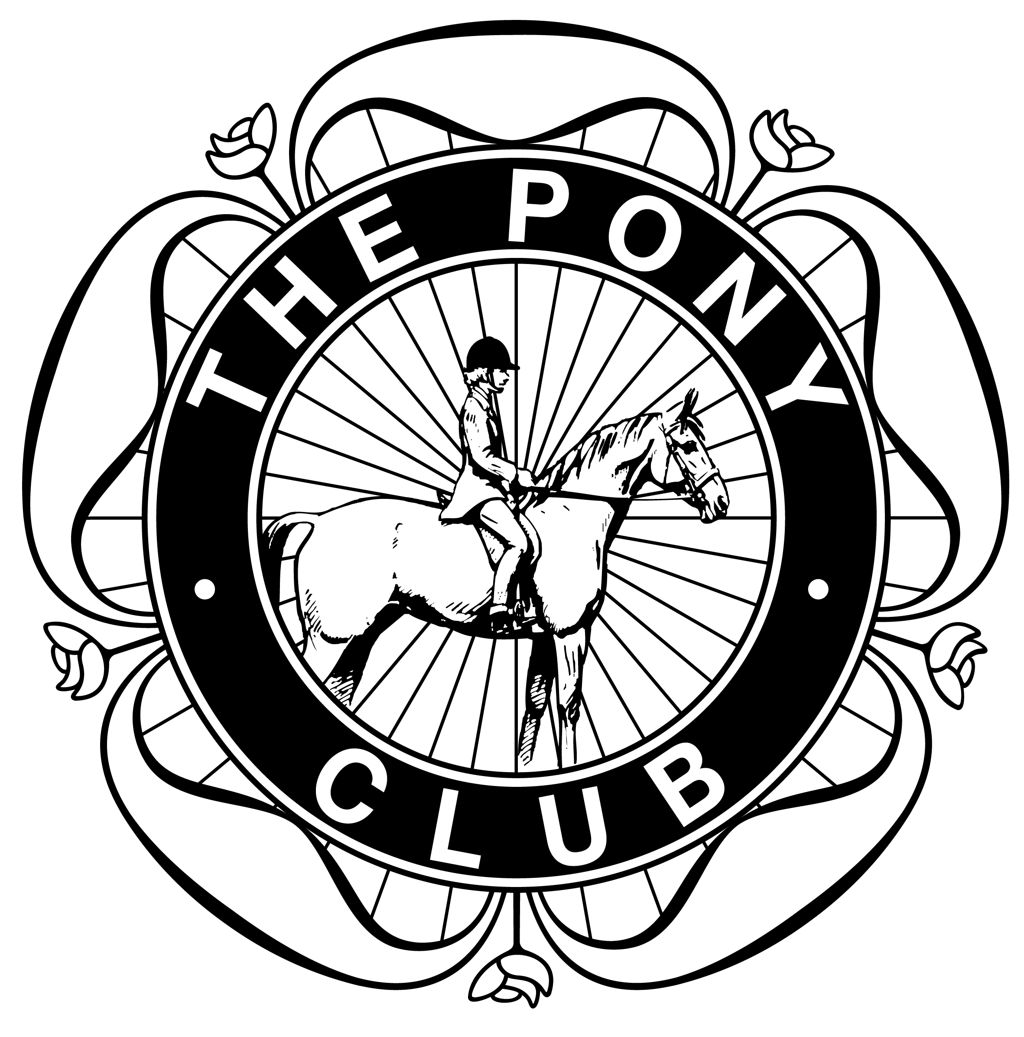
Winter League & Interbranch
Team & Individual Show Jumping Competition
Southview Equestrian Centre
Wettenhall Green, Winsford Road, Wettenhall, Cheshire, CW7 4DL
Saturday 5th December 2015

Class Category Approx. 1st round height
- Juniors 10yrs and under 2’3” /68cm
- Novice 13yrs and under 2’6” /76cm
- Intermediate Any Age 2’9”/ 84cm
- Dengie Qualifier 2’11”/ 90cm

Open Any age 3’ 3”/ 1m

Classes to be run under Pony Club Team Show Jumping rules with 2 rounds and no 3rd round jump-off and in accordance with Area 5 Winter League Rules 2011 to accommodate WL and non-WL teams and individuals with appropriate course changes.

Age as at 1 January 2015
Entry Fee: £14.00 per competitor for classes 1-2-3&5 Entry fee for class 4 Dengie Qualifier £16
Cheques to: Cheshire Hunt South P C

Entries to: Caroline Topping
Address: Windyhowe Cottage, Delamere, Northwich, Cheshire, CW8 2JG
Telephone: 07710 082989
Email: ct@toppingsales.com
Entries close: Saturday 28 November 2015
Any team changes following entry must be made by Wednesday 2 December latest, due to other commitments.

Entries must be signed by branch DC.

Rosettes: Teams and individual to 6th place
Prizes: 1st to 3rd Team and Individual
This competition is for teams of 3 or 4. Competitors will jump two rounds. The best 3 scores will count. The second round will be timed and used in the event of a tie and for individual placings. Any individual entries may be placed in a mixed team.

Course walk for Class 1: 8.30 for 9.00 start. Contact number on the day 07711 626865.

Refreshments will be available

Photographic Rights By entering any of the classes at this competition, competitors and their parents/guardians give permission for any photographs and/or videos taken of persons or equines to be used and published in any media whatsoever for editorial purposes, press information or advertising by, or on behalf of, the organizers.

Disclaimer of Liability Neither the organisers of this event nor the Pony Club, nor any agent, employee or representative of these bodies accepts any liability for any accident, loss, damage, injury or illness to horses, riders, owners, spectators, land, cars, their content and accessories or any other person or property whatsoever, whether caused by their negligence, breach of contract or in any way whatsoever.
Health and Safety the organizers of this event have taken all reasonable precautions to ensure the health and safety of everyone present. For those measures to be effective, everyone must take all reasonable steps to avoid and prevent accidents occurring and must obey the instructions of the organizers and all officials and stewards.

