Pony Club Polocrosse
Training & Chukkas Day
Sunday 5th July 2015
10am – 4pm
Rake Lane, Backford, Cheshire

Celyn Polocrosse Club are hosting training and chukkas day on Sunday 5th July at their Cheshire grounds. This event is open to all Pony Club members of all ages and abilities, and will include training in the morning and then fun chukkas in the afternoon.

Training will be carried out by UKCC coaches, led by Tom Simkin (Pony Club Polocrosse Chief Coach and UKPA Chief Coach). Sticks are available to borrow; all your pony will need is bandages and over reach boots on all four legs and a breastplate.

Cost £25 per player

Payment can be made by cash/cheque (made payable to ‘Celyn Polocrosse Club’ ) on the day or by BACS to account 02265078 Sort Code 30-97-62. Please email your booking form to the address below by Wednesday 1st July 2015.

For further information please see the website at www.celynpolocrosse.co.uk or contact Anna Tarbuck: anna@celynpolocrosse.co.uk or call 07749 960955.

For additional directions to the site please see the ‘Find Us’ section of the Celyn website. The best postcode is CH2 4DF, but continue on past this point to arrive at the field.

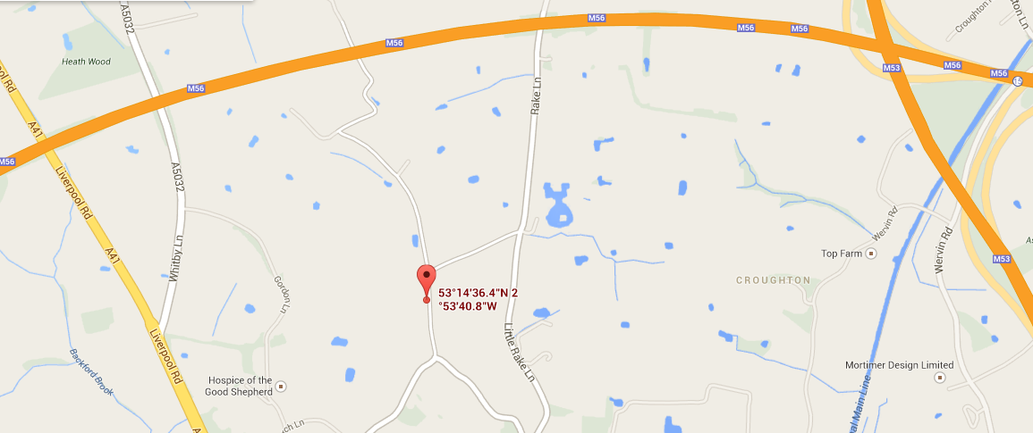

PONY CLUB POLOCROSSE TRAINING DAY BOOKING FORM

To book please complete the following information and return to Anna Tarbuck at anna@celynpolocrosse.co.uk by Wednesday 1st July 2015.

Name
Branch/Centre
UKPA grading or skill level
Contact No.
E-Mail Address
Age
Size of Pony
I am paying by … | Cash/Cheque |  | BACs

Payment may be made by cash/cheque made payable to ‘Celyn Polocrosse’ , or by BACS to account 02265078 Sort Code 30-97-62 with the reference JULY TRAINING.

Please note that all under-18s MUST have a designated supervising adult on site at all times.

CELYN POLOCROSSE – PLAYER DETAILS

Section A (not required for Celyn Players)

PLAYER NAME: ..…………………………………………………………………………………

AGE (as at 1st Jan): ……………………………… Today’s Date: …………………………….

Any Medical conditions which may affect you while playing or practising polocrosse on foot or on horseback?

………………………………………………………………………………………………………..

………………………………………………………………………………………………………..

………………………………………………………………………………………………………..

RISK STATEMENT

Polocrosse is classed as a RISK SPORT such that there remains a risk of serious injury while playing the sport. Injuries may occur while you are practising or competing both on horseback and on foot.

All persons taking part in, or as spectators of, Celyn/UKPA activities do so at their own risk.

The UKPA and Celyn club, their officers and agents accept no liability for loss, damage or injury to persons, animals or property other than that required by statutory legislation.

By signing below (or signing on behalf of a junior) you are accepting the above Risk Statement for yourself and/or the player

Signed: ………………………………………. Print Name:……………………………………….

Section B – For all Players Under the Age of 18 years on the Day (for all as applicable)

If the player is not to be accompanied by their parent/guardian then please declare here the adult designated with on site responsibility:

…………………………………………………………. …………………………………………….

Signed: ………………………………………. Print Name:……………………………………….

