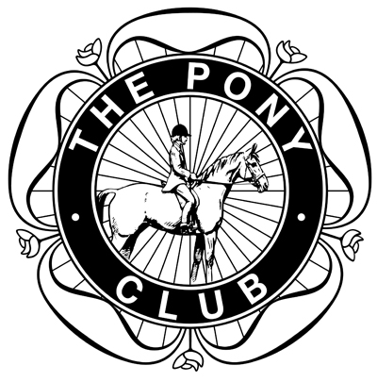

You are invited to
The Three Counties Area 9
Pony Club

CHAMPION HEADWEAR

PONY RACING DAY
Kindly sponsored by Calmsden Limited

On Friday 3rd April 2015

To be held on
THE AMAZING HALLOWED TURF AT

First Race 1.30pm.

Entries Close : Wednesday 25th March 2015
Schedule

Race 1. Ponies 128cm and Under. Open
No minimum weight. Distance 6 furlongs approx. Entry Fee - £25.00

Race 2. Ponies 138cm and Under. Novice Riders. Riders not to have been placed 1st in any Pony Race
No minimum weight. Distance 6 furlongs approx. Entry Fee - £25.00

Race 3. Ponies 138cm and Under. Combinations must not have been placed 1st or 2nd in any Pony Race. No minimum weight. Distance 6 furlongs approx. Entry Fee - £25.00

Race 4. 138cm & Under OPEN
Ponies 138cm and Under. *Minimum weight 7 stone 10lbs*.
Distance 6 furlongs approx. Entry Fee - £25.00
Tim Spencer-Cox Friendship Trophy will be presented to the highest placed rider from Area 9

Race 5. Ponies 148cm and Under. Novice Riders. Riders not to have been placed 1st in any Pony Race
No minimum weight. Distance 8 furlongs approx. Entry Fee £25.00

Race 6. Ponies 148cm and Under. Combinations must not have been placed 1st or 2nd in any Pony Race. No minimum weight. Distance 8 furlongs approx. Entry Fee - £25.00

Race 7. 148cm & Under OPEN
Ponies 148cm and Under. OPEN.
*Minimum weight 9 stone 0 lbs* Distance 8 furlongs approx. Entry Fee - £25.00
The Area 9 Perpetual Trophy will be presented to the highest placed rider from Area 9

*No lead weight will be supplied please bring your own

The organizers of the event reserve the right to cancel the event or any class, to alter the advertised times, to divide any class, and to refuse entry with or without stating a reason..

RULES are now available to download from The Pony Club website or buy a copy from PCHQ for £3.00.
www.pcuk.org

Entries Secretary:
Mrs S Marquand
Cora Cottage, Cutsdean
Cheltenham, Gloucestershire, GL54 5RX
Tel : 01386 584591/ mob 07968230934
Email shelley-marquand@hotmail.co.uk

Cheques to be made payable to: Area 9 Pony Racing
Doctor, Veterinary Surgeon & Paramedics will be in attendance
STRICTLY NO DOGS
PONY CLUB POINTS SERIES FOR 2014 SEASON

Points will be awarded to all pony/rider combinations who take part in 128cm, 138cm & 148cm Pony Club Pony Races in 2015.
At the end of October (or after the last race day), a prize will be given to the highest placed pony/rider combination in the three height categories.

THE AREA 9 PONY CLUB RACING COMMITTEE are this year putting forward an Award for a chosen Jockey to take a place at The British Racing School Summer Camp – 4th – 8th August 2015. - (Age 11-15 years) – Level 1 Pony Racing Day can be arranged if not already achieved.

The successful Jockey will be selected from the Entries from Area 9 Branches at Cheltenham on 3rd April 2015.

DO NOT DELAY PLEASE APPLY on the Application Form which is attached to your Entry Form.

GOOD LUCK !!

APPLICATION FORM

Area 9 are this year putting forward an Award for further Training which will take place at the British Racing School Newmarket.

A place at The British Racing School Summer Camp
4th – 8th August 2015 (Ages 11-15 years)
Plus Level 1 Pony Racing Day if not already achieved

The lucky Jockey will be selected from the Entries from Area 9 Branches at Cheltenham on 3rd April 2015.

All Jockeys aged 11 – 15 years are eligible for this Training Award which will be presented after the last Race of the day – selection for this will be made by the Area 9 Racing Committee.

To give the Area 9 Racing Committee a background history of your riding/pony racing experience please complete the section below and return with your Entry Form. This will enable the Committee to make a fair assessment when selecting a Candidate for this amazing prize.

WE WOULD LOVE TO HEAR FROM YOU !!

........................................................................................................................

NAME .....................................................................................................................

ADDRESS ...............................................................................................................

TELEPHONE NUMBER ........................................AGE.....................................

PONY CLUB BRANCH .........................................................................................

Please write a short resume of your experience to date and your ambitions for the future : (Please add a separate sheet if so required).

