RULES

The committee or land owners cannot be held responsible for any damage, loss or injury to persons, horses or property.

The decision of the committee and judges will be final.

The committee reserves the right to cancel any classes if insufficient number of entries.

Any persons competing or otherwise, when mounted, must wear protective headgear with the harness properly adjusted and fastened at all times

Riders must be in PC or competition dress and conduct themselves appropriately. Age is taken as on 1st Jan 2013.

This competition is open to Pony Club Members.
The Dengie qualifier classes are open to non Pony Club Members.

Pony Club members must hold a valid spur card.

Aggressive behaviour, foul language, excessive use of spurs or whips by riders, handlers and/or spectators WILL NOT be allowed and offenders will be asked to leave the event.

All horse and ponies must be over four years old.

All dogs must be kept on leads at all times.

Please DO NOT leave litter or muck out trailers or lorries on the parking area.

No refunds will be given except for cancellation of classes or the competition.

HALF TERM
DRESSAGE COMPETITION including
DENGIE
WINTER LEAGUE DRESSAGE
ROSETTES TO SIXTH PLACE IN ALL CLASSES

FRIDAY NOVEMBER 1, 2013

Maelor Equestrian Centre
LL12 9SD

ENTRIES IN ADVANCE
Entries close October 26, 2013
CLASSES ONLY £10
DENGIE CLASSES £12

DENGIE CLASSES OPEN TO NON PONY CLUB MEMBERS

FOR MORE DETAILS PLEASE CONTACT:
Jenny Williams: 07584 252643
e-mail: jwilliams89@btinternet.com

REFRESHMENTS AVAILABLE ON DAY

ABERCONWY BRANCH 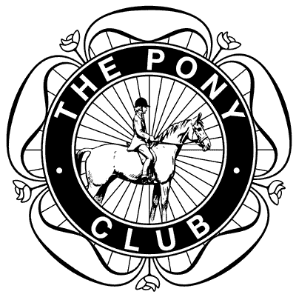
OF THE PONY CLUB

HALF TERM DRESSAGE COMPETITION
WITH DENGIE QUALIFYING CLASSES

CLASS 1
NEWCOMERS (LIMITED ENTRIES) Pony Club D level Walk & Trot (2012) Test

CLASS 2
INTRODUCTORY (LIMITED ENTRIES)
Pony Club Introductory (2007) Test

CLASS 3
NOVICE (DENGIE QUALIFIER)
Pony Club Novice (2009) Test
Preliminary Round

CLASS 4
INTERMEDIATE (DENGIE QUALIFIER)
Pony Club Intermediate (2013) Test
Preliminary Round

TESTS MAY BE CALLED IN ALL CLASSES

PLEASE NOTE: Non-Members of The Pony Club are allowed to compete in Preliminary Rounds but must become fully
paid-up Members to compete at their Area Competition.

ENTRY FORM

CLASS NO. | RIDER NAME  BRANCH NAME | HORSE/PONY NAME | AGE  (at Jan 1) | ENTRY FEE
TOTAL: £
DC OR BRANCH SECRETARY SIGNATURE

CLOSING DATE: OCTOBER 26, 2013

PLEASE POST ENTRIES AND PAYMENT TO:
THE COMPETITIONS SECRETARY: JENNY WILLIAMS
YR HEN FEUDY, FFORDD BRYN SAITH,
LLANDDOGED, CONWY LL26 0AZ
(07584 252643)

CHEQUES SHOULD BE MADE PAYABLE TO:
ABERCONWY PONY CLUB

CONTACT DETAILS IN CASE OF QUERY OR CANCELLATION
NAME
ADDRESS
CONTACT NUMBER
E-MAIL

