Sunday 17th November 2013
Novice & Open Pony Club Dengie Winter League Dressage Preliminary Round Competition

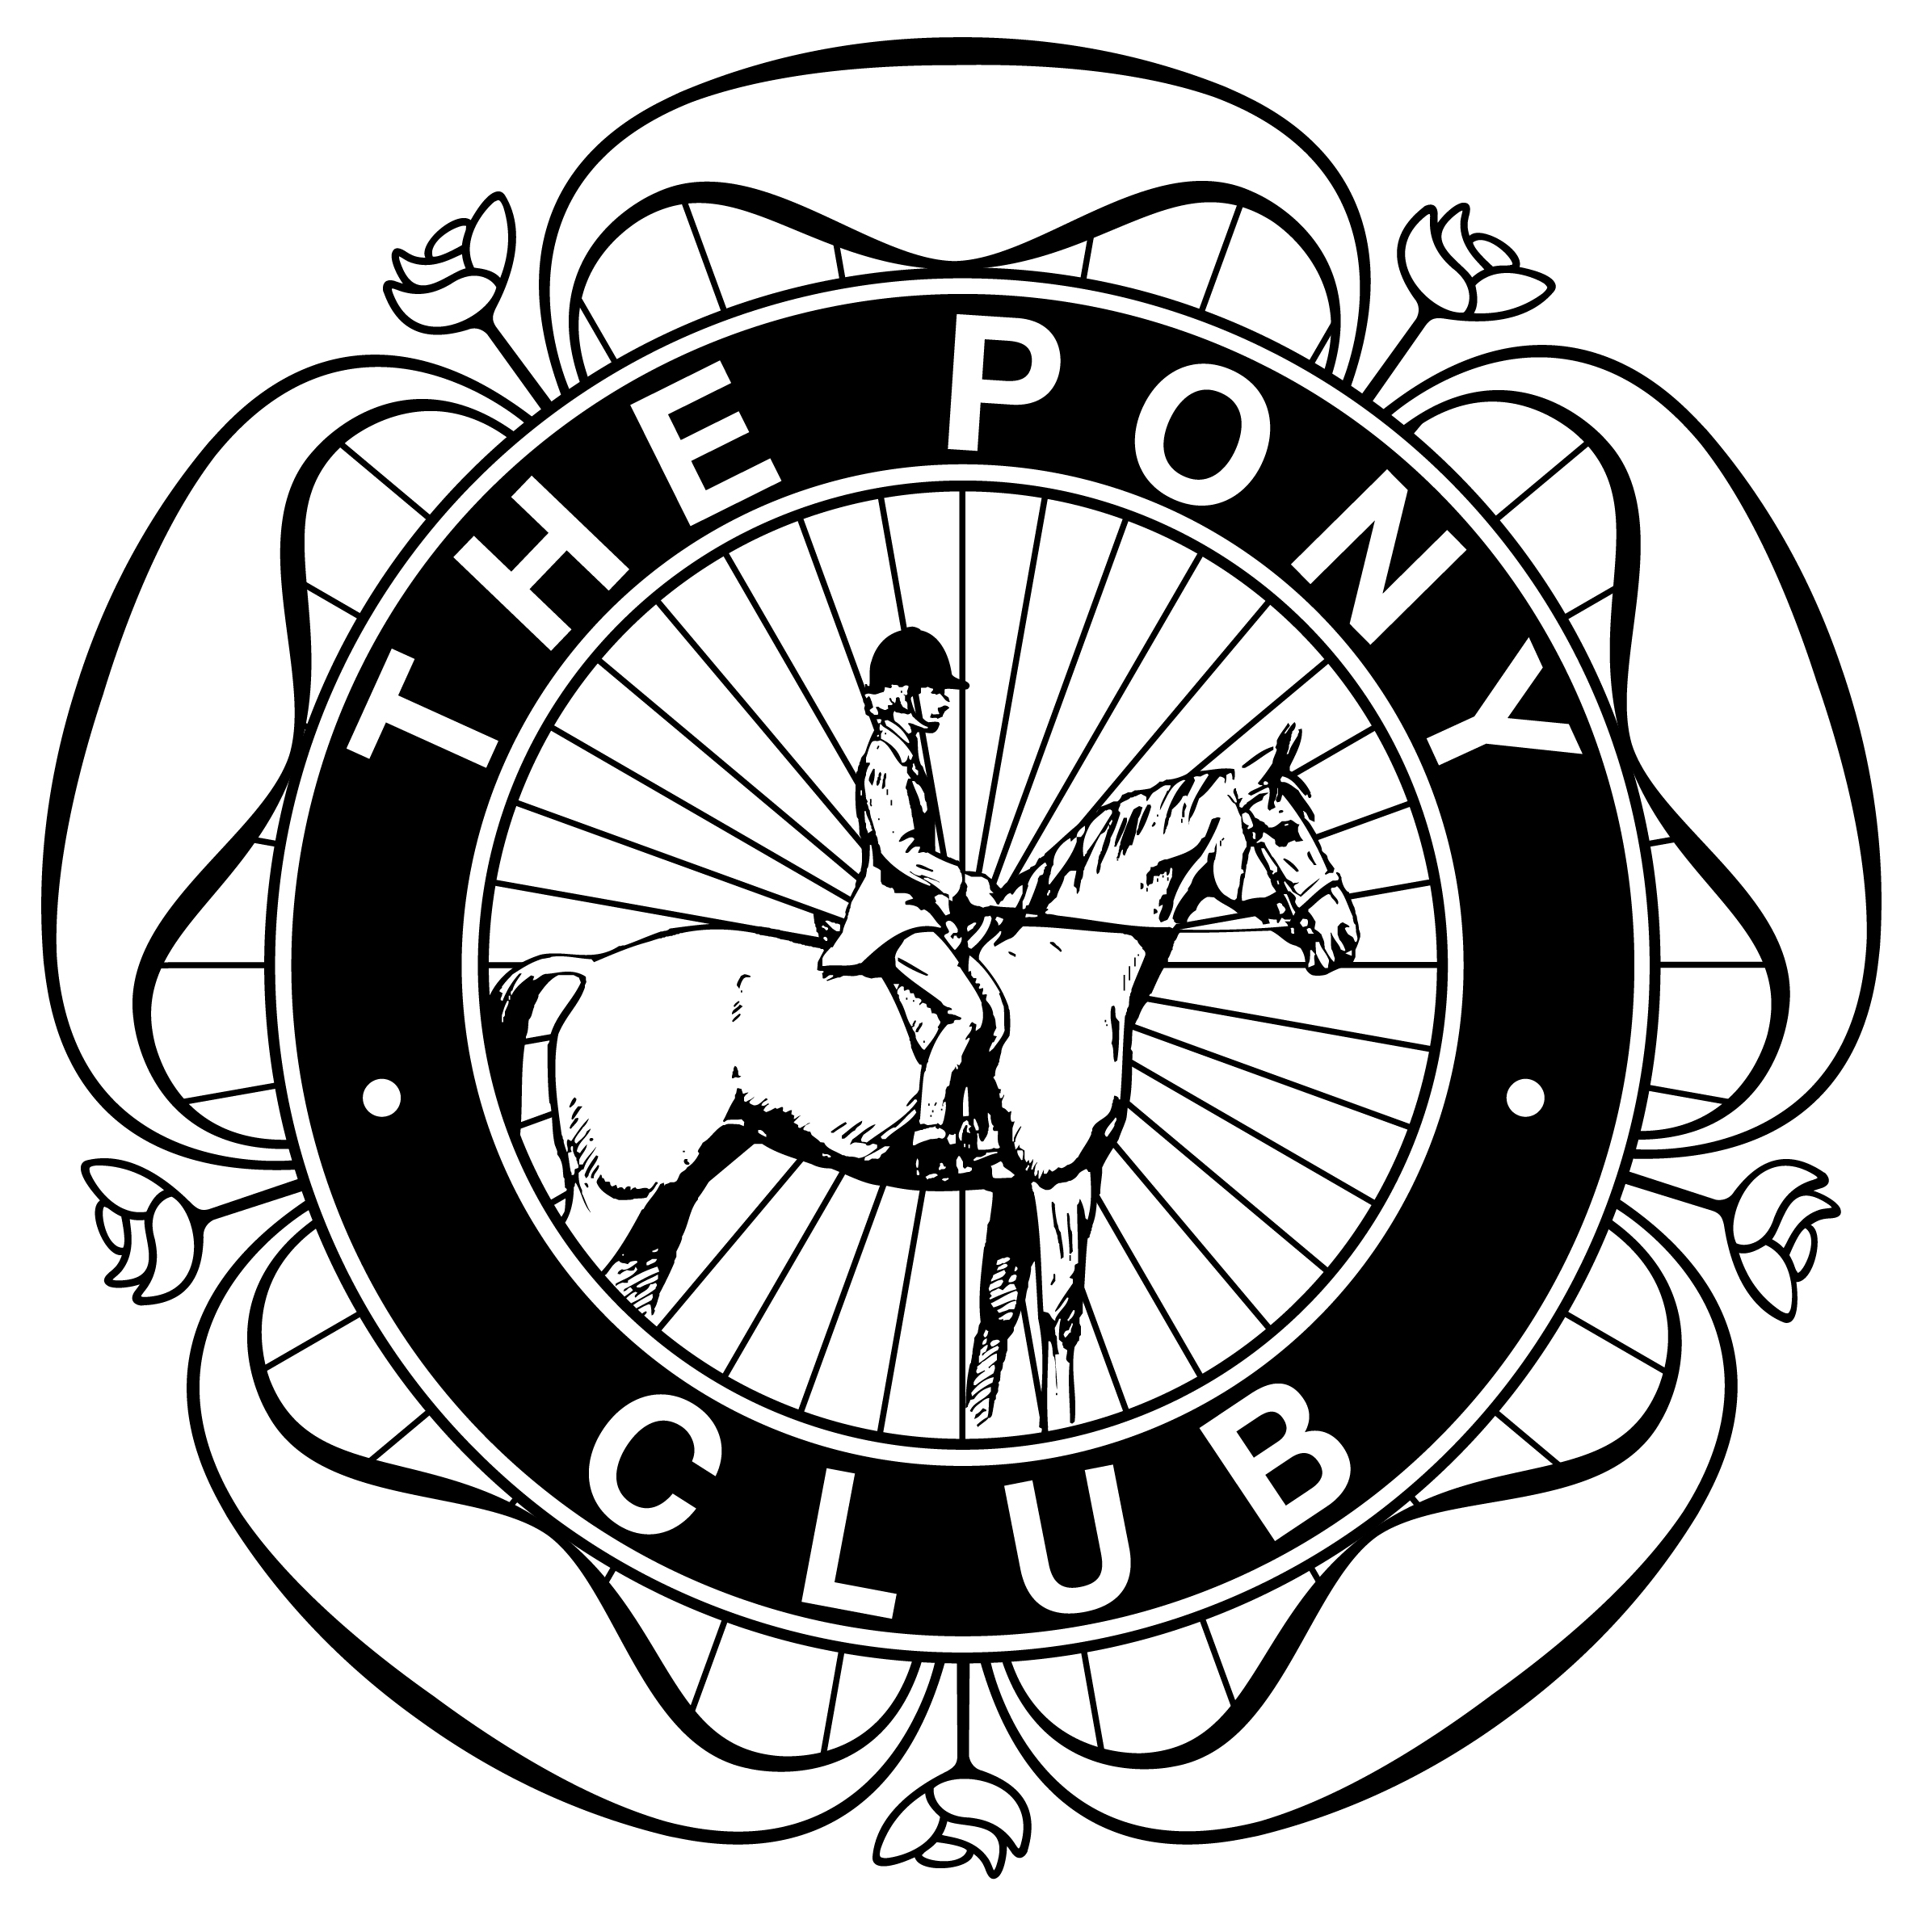
Huntersgate, Byley, Cheshire, CW10 9LW

Class 3 - Novice Dengie Qulaifier (Pony Club Novice Dressage Test 2009)
Class 4 – Open Dengie Qualifier (Pony Club Intermediate Dressage Test 2013)

Entries on the official entry form to Liz Sutton, Yew Tree Farm, Bexton Lane, Knutsford WA16 9BH Tel 07736145761
Closing date Saturday 9th November 2013. Times displayed on CHNPC website www.cheshirehuntnorthpc.com
Name, Address & postcode, Tel number

Class | Name of rider | Age of rider  As of 1.1.13 | Name of horse | Branch | Entry fee  £14 per class
Total entry fees enclosed:

Signature of District Commissioner _____________________________________ Signature or parent (if under 18) _____________________________________

Cheques payable to CHNPC

