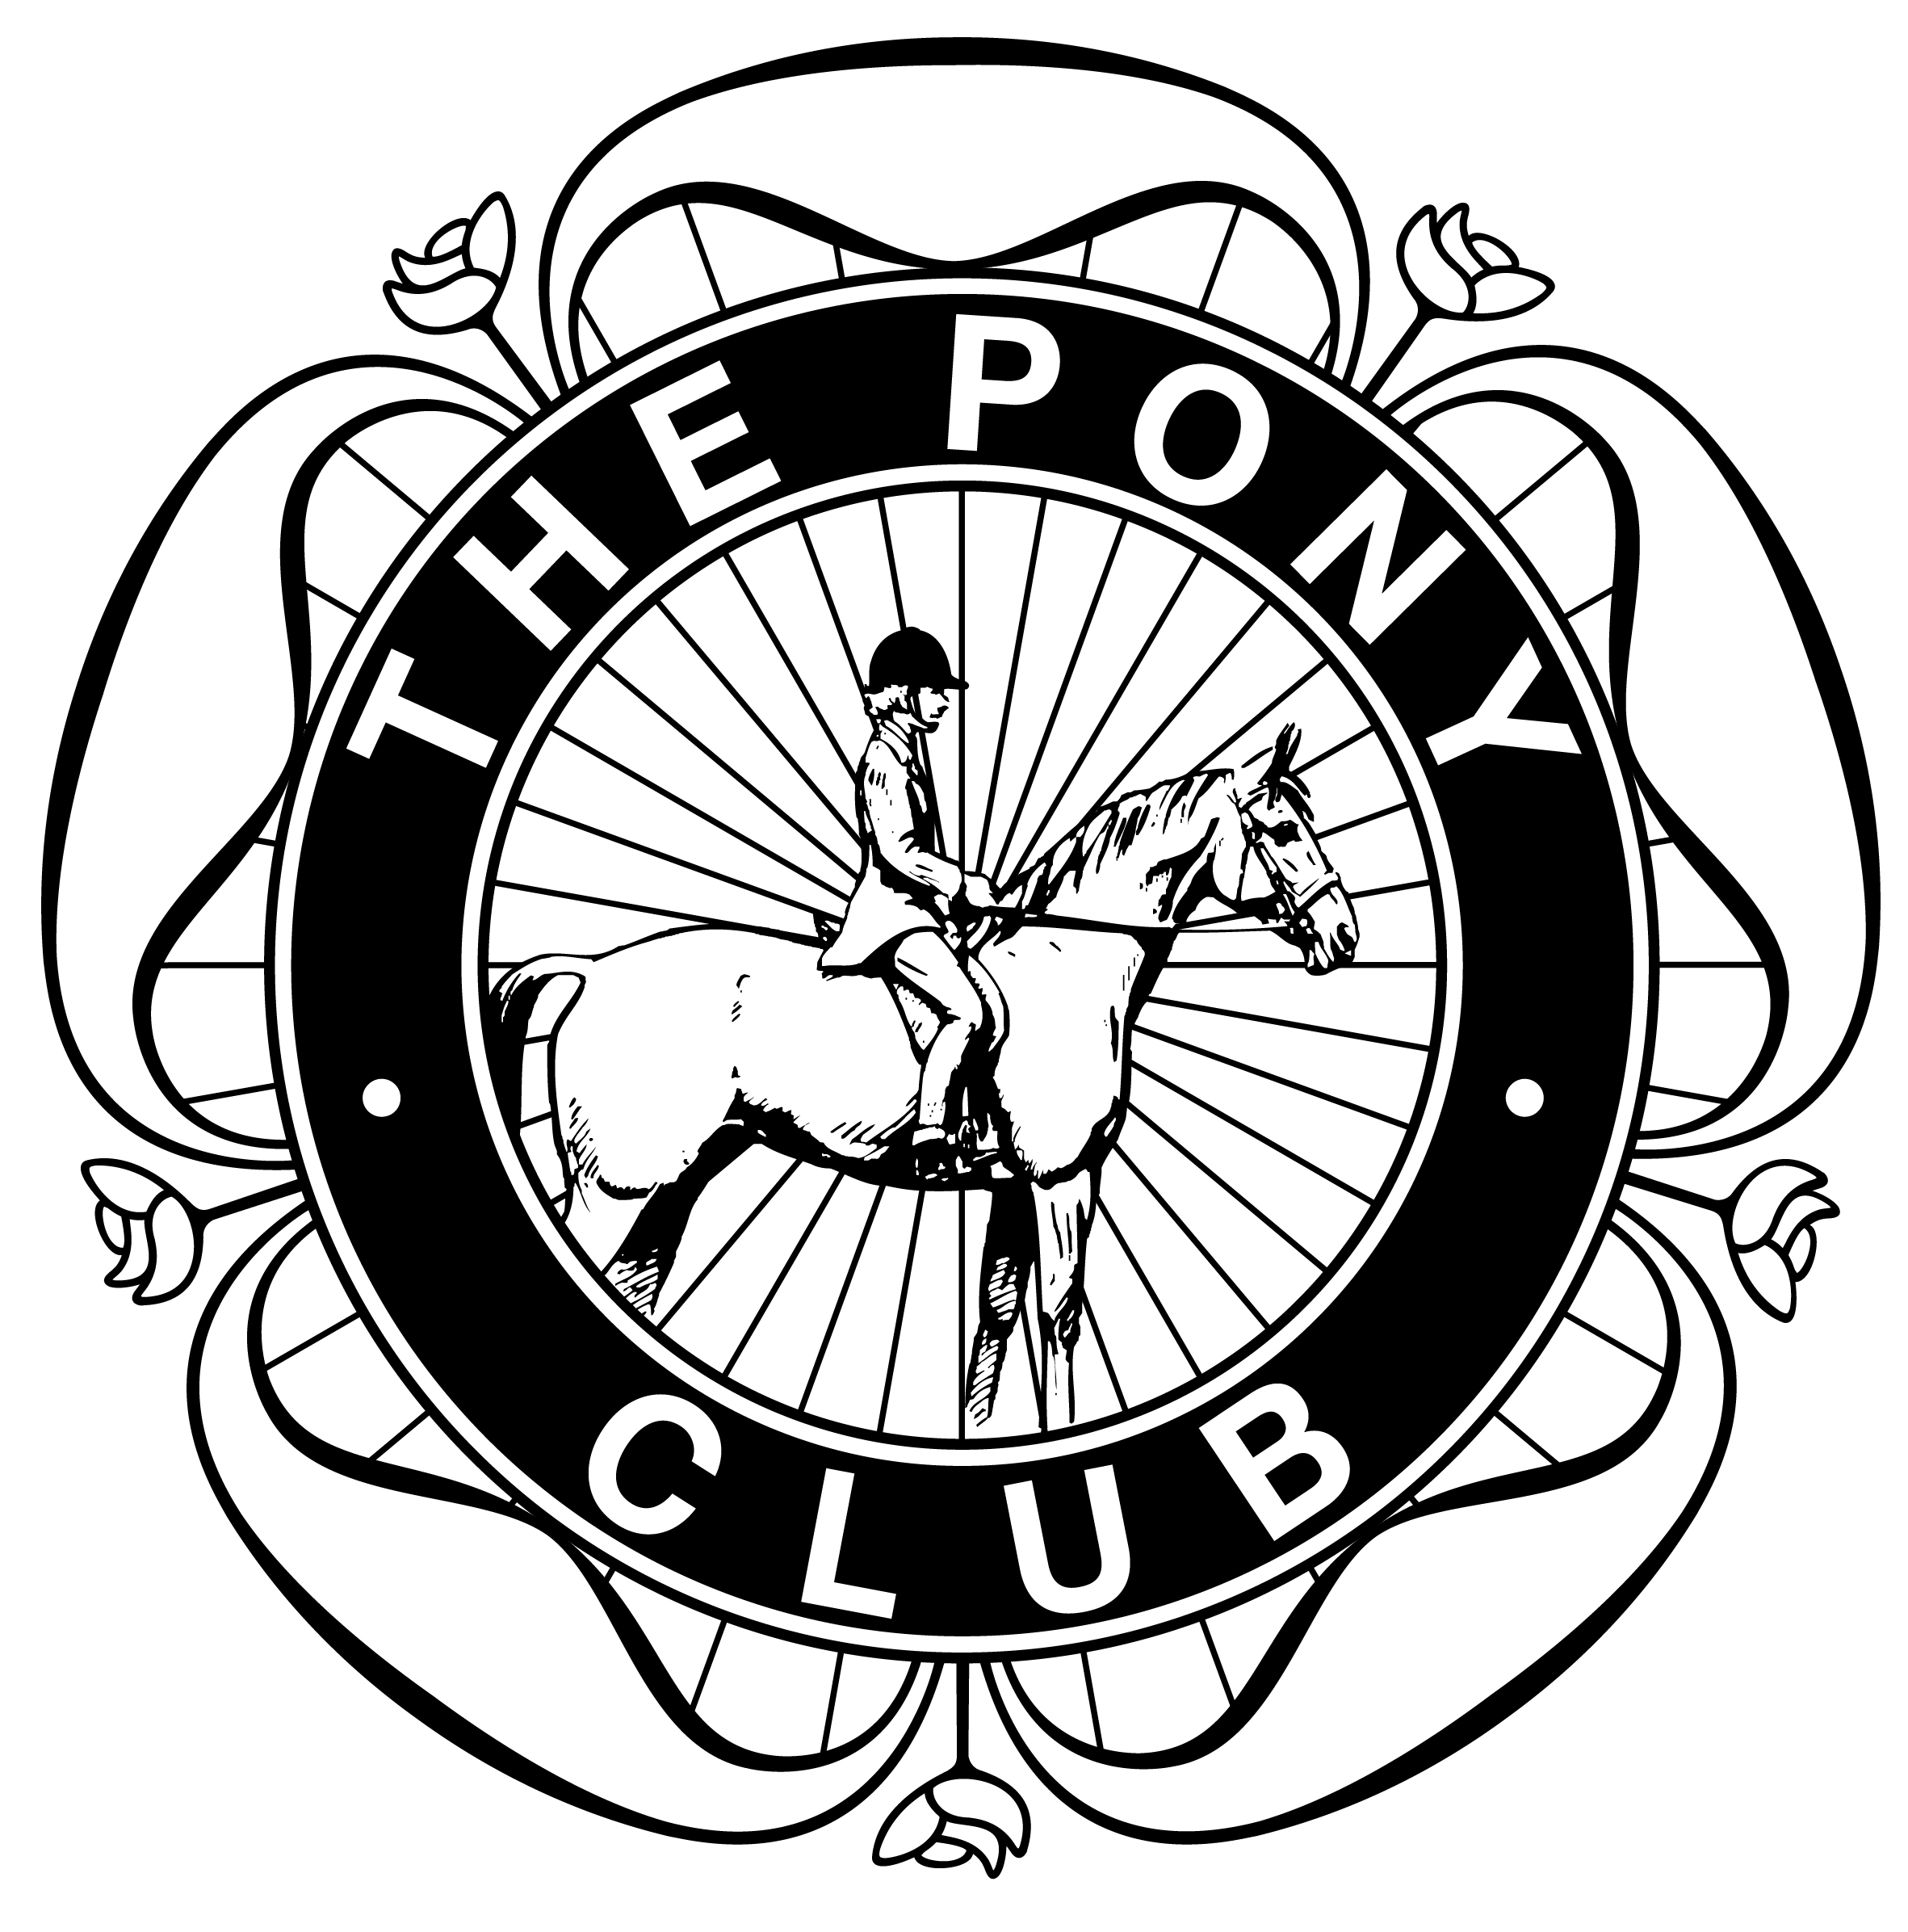
SAFEGUARDING AND PROTECTING CHILDREN WORKSHOP
Delivered by THE PONY CLUB
and recognised by the BEF and Sport England
Please fill in your details below if you wish to attend the Course
Cost of Course: £ 20
(Candidates must be 18 years or over)
I……………………………………………………………………………….(Print Name)
wish to attend the Safeguarding and Protecting Children Workshop at Cross Foxes, Brithdir, Dolgellau, Gwynedd, LL40 2SG on Monday, 23rd September, 2013, starting at 7.00 p.m.

Cheque for: £ …………….. is attached to this form.
Signed: ………………………………………………………….
Print Name: …………………………………………………………………………………………….
Address………………………………………………………………………………………………....
……………………………………………………………………………………………………………
………………………………………………………….Postcode ……………………………………
Area ……………………………………………………
Pony Club Branch/Centre: ………………………………………………………
Email address: ……………………………………………………………………
Please return cheque (made payable to The Pony Club) and form to:
Hannah Clack, The Pony Club, Stoneleigh Park, Kenilworth, Warwickshire, CV8 2RW, as soon as possible. Certificates will be sent after the Course.

Closing Date for Applications : 22nd September, 2013
ATTENDEES MUST REGISTER THROUGH THE PONY CLUB OFFICE AND PAY THE REQUIRED FEE, OTHERWISE THEY WILL NOT BE ALLOWED TO ATTEND
(COURSE NUMBERS WILL BE LIMITED TO BETWEEN 12 – 24 ATTENDEES)

