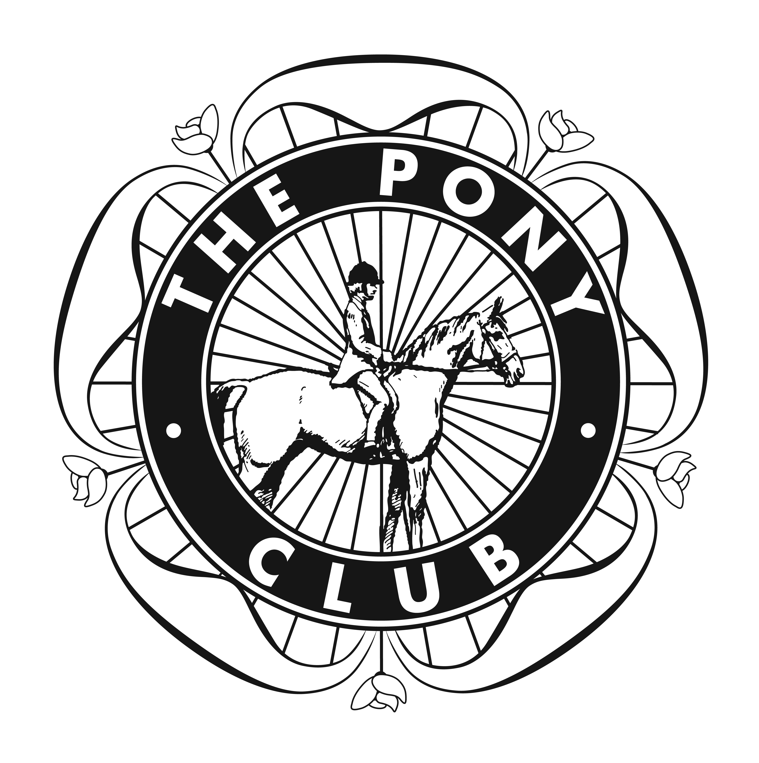

The nominated charities are The Shropshire Air Ambulance and The League of Friends of the Orthopaedic Hospital, Gobowen.

**Objections.**

Objections must be made within half an hour of the incident or after the scores have been published or after the dressage sheets have been released. The official steward will give a decision which will be final.

**Directions.**

Post code for Sat Nav users: SY10 7EJ. Sign posted from the A5.

**Disclaimer of Liability.**

Save for death or personal injury caused by the negligence of the organisers or anyone whom they are in law responsible, neither the organisers of this event nor the pony club, riding club, nor any agent, employee or representatives of these bodies accepts liability for any accident, loss, damage, injury or illness to horse, riders, owners, spectators, land or vehicles, their content and accessories or any other person or property whatsoever whether caused by negligence, breach of contract or in any way whatsoever. Non PC members must provide information of their insurance cover.

**Health and Safety.**

The organisers of this event have taken all responsible precautions to ensure the health and safety of everyone present. For those measures to be effective, everyone must take all responsible steps to avoid and prevent accidents occurring they must obey instructions of the organisers or their representatives.

 

**Berwyn and Dee Branch of the Pony Club**

**And**

**Vyrnwy Valley Riding Club**

**CHARITY**

**Beginners One Day Event.**

To be held at Daywell Manor, Gobowen

Oswestry, SY10 7EJ.

Saturday 24th August 2013

Entries close 14th August 2013

Times available from;

[www.berwynanddee.co.uk](http://www.berwynanddee.co.uk) or [www.v-vrc.com](http://www.v-vrc.com)

Refreshments available courtesy of Thistle Catering. 01631 638320.

Veterinary cover by Fyrnwy Equine Clinics.