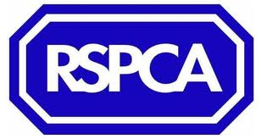 | FUN SHOW !!!  Sunday 19th August  Tyrnog Livery, Y Wern, Llandyrnog, Denbighshire  LL16 4HW
Fun Classes start at 11am
Classes £2.00 each or 3 for £5 (Rosettes to 6th place)

11.00 | Fancy Dress | Best costume wins!!
11.20 | Walk, Trot, Canter | Ride each part as fast as you can...but not too fast!
11.40 | Potato Race | Race to collect potatoes and drop them in buckets!
12.00 | Musical Buckets | Like musical chairs......but with horses and buckets!
12.30 | Obstacle race | Get round our silly obstacle course in the fastest time!

Jumping starts 1pm
Clear round £2, other classes £4 (Trophies for winners, rosettes to 6th place)
 |  | Max Height
1.00 | Mini Clear Round | 1ft
1.30 | Mini & Lead-rein | 1ft
2.15 | Clear Round | 2ft
3.00 | Beginners Novice | 1ft 9
3.45 | Novice | 2ft 3
4.00 | Pairs (relay) | 2ft
4.45 | Open | 3ft

Join us on facebook (search for ‘RSPCA Fun Horse Show’) or e-mail Lucy at loooey@hotmail.com, so that if we have to postpone due to bad weather we can let you know!

