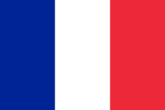
Flags from Equestrian Nations
Country | Capital | Flag | Equestrian discipline
United Kingdom | London | 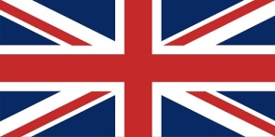 | Discipline – Racing  Breed –  Thoroughbred  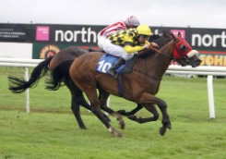
Ireland | Dublin | 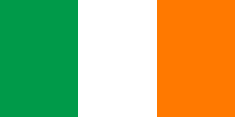 | Discipline – Fox hunting  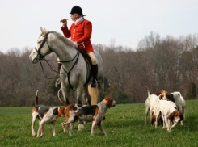  Breed –  Irish Draft
Australia | Canberra | 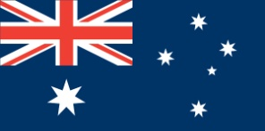 | Discipline - Drovers  Breed –  Australian Stock  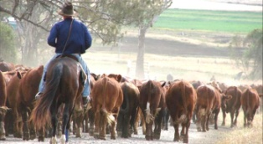  Horse
Argentina | Buenos Aires | 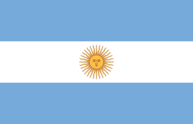 | 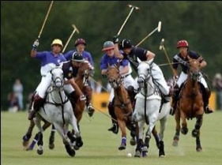  Discipline – Polo  Breed –  Polo pony
Germany | Berlin | 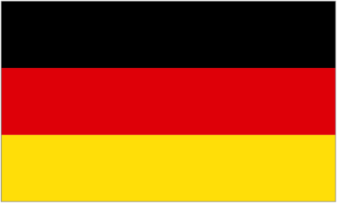 | 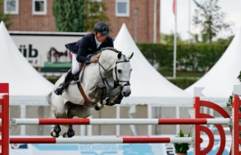  Discipline-  Show Jumping  Breed –  Hanoverian
Netherlands | Amsterdam | 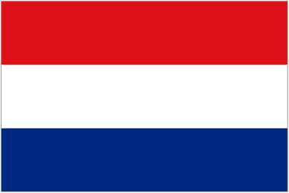 | Discipline –  Dressage  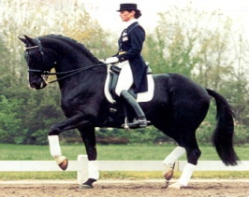  Breed –  Dutch Warmblood
Saudi Arabia | Riyadh | 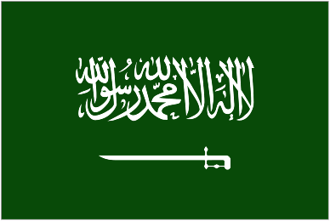 | 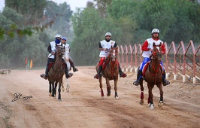  Discipline –  Endurance racing  Breed –  Arab
United States of America | Washington D.C | 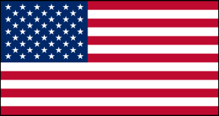 | 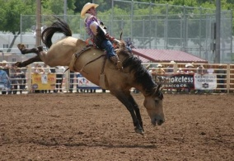  Discipline –  Cowboys / Rodeo  Breed –  Mustang
Canada | Ottawa |  | Discipline - Canadian Mounted Police ‘Mounties’  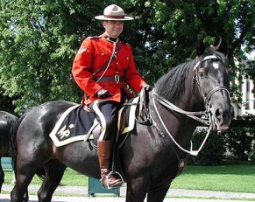  Breed -The Canadian Horse
France | Paris | 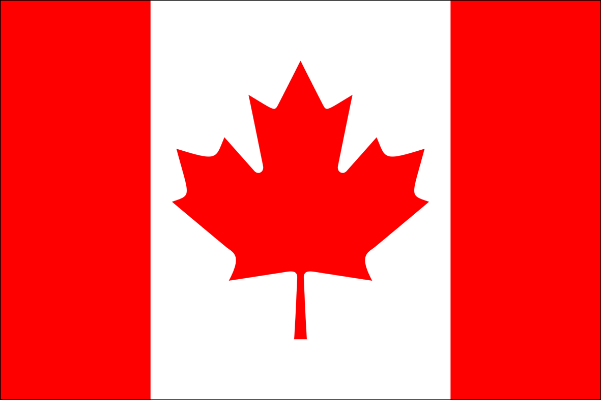 | Discipline –  Eventing  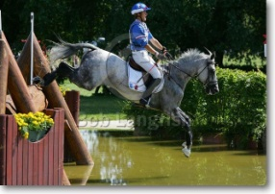  Breed –  Selle Francais

