RULES

The committee or land owners cannot be held responsible for any damage, loss or injury to persons, horses or property.

The decision of the committee and judges will be final.

The committee reserves the right to cancel any classes if insufficient number of entries.

Easter eggs will be presented to all competitors in Class One.

Any persons competing or otherwise, when mounted, must wear protective headgear with the harness properly adjusted and fastened at all times

Riders must be in PC/competition dress and conduct themselves appropriately. Age is taken as on 1st Jan 2012.

This competition is open to Pony Club members only and a valid spur card must be held, where necessary.

Aggressive behaviour, foul language, excessive use of spurs or whips by riders, handlers and/or spectators WILL NOT be allowed and offenders will be asked to leave the event.

All horse and ponies must be four years old or over.

All dogs must be kept on leads at all times.

Please DO NOT leave litter or muck out trailers or lorries on the parking area.

No refunds will be given except for cancellation of classes or the competition.

ABERCONWY

BRANCH OF THE PONY CLUB

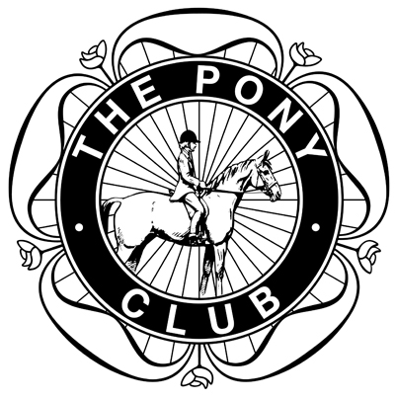

COMBINED TRAINING COMPETITION

April 6, 2012 (Good Friday)

Maelor Equestrian Centre
Hope, Flintshire. LL12 9SD
09.00am START

ROSETTES TO SIXTH PLACE IN ALL CLASSES
EASTER EGGS TO THE WINNERS

ENTRIES IN ADVANCE
DRESSAGE & SHOW JUMPING £15
DRESSAGE ONLY £8

DRESSAGE TESTS AVAILABLE ON PCUK WEBSITE

FOR MORE DETAILS PLEASE CONTACT:
Jenny Williams 07584 252643
jwilliams89@btinternet.com

DRESSAGE TIMES WILL BE PUBLISHED ON ABERCONWY PC WEBSITE FROM TUESDAY EVENING APRIL 3, 2012

REFRESHMENTS AVAILABLE ON DAY

COMBINED TRAINING COMPETITION
DRESSAGE AND SHOW JUMPING

CLASS 1 ASSISTED (LIMITED ENTRIES)
DRESSAGE: PC D Level (Walk and Trot Test) 2012
SHOW JUMPS: Max height 45cms
RIDERS UNDER 10 YEARS * LEAD REINS PERMITTED

CLASS 2 NEWCOMERS
DRESSAGE: PC D Level (Walk and Trot Test) 2012
SHOW JUMPS: Max height 60cms

CLASS 3 NOVICE
DRESSAGE: PC Novice Test 2009
SHOW JUMPS: Max height 75cms

CLASS 4 INTERMEDIATE
DRESSAGE: PC Intermediate Test 2009
SHOW JUMPS: Max height 90cms

CLASS 5 OPEN
DRESSAGE: PC Open Test 2008
SHOW JUMPS: Max height 1m

* TESTS MAY BE CALLED IN ALL CLASSES *

ENTRY FORM

CLASS NO. | RIDER  NAME | HORSE/PONY NAME | AGE  (at Jan 1) | ENTRY FEE
TOTAL: £
NAME OF BRANCH AND DC OR BRANCH SECRETARY SIGNATURE

CLOSING DATE: MARCH 20

PLEASE POST ENTRIES AND PAYMENT TO:
THE BRANCH SECRETARY: SANDIE MONKS
HAULFRYN, LLANDDOGED, CONWY
NORTH WALES LL26 0BZ
(07780 335231)

CHEQUES SHOULD BE MADE PAYABLE TO:
ABERCONWY PONY CLUB

CONTACT DETAILS IN CASE OF QUERY OR CANCELLATION
NAME
ADDRESS
CONTACT NUMBER
E-MAIL

