**BANGOR ON DEE POINT TO POINTS**

**2012**

** *NEW\***  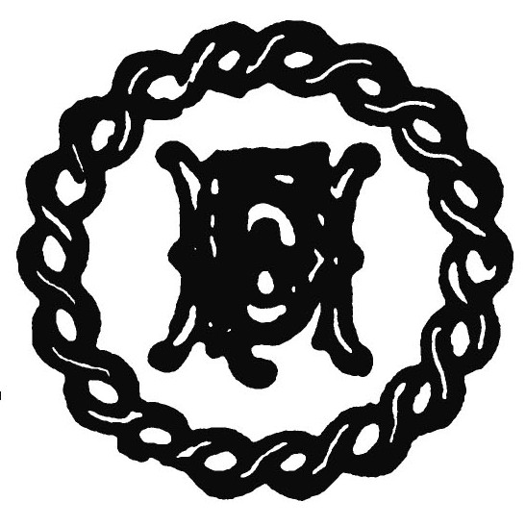

**Horse and Hound**

**Bring and Buy Sale**

To be held

Sir W W Wynn’s Point to Point March 11th 2012

&

Flint and Denbigh May 27th 2012

**Fantastic opportunity to make some cash by selling your unwanted hunting and horsey paraphernalia**

**20% commission to hunt funds**

Clean out your tackrooms and attics for:- Hunting coats, breeches, crops, horns, boots and trees, waistcoats, spurs, books, ornaments, hip flasks etc

Sell those no longer used, outgrown horse items:- Tack, bits, stirrups, girths, rugs, etc etc

Plus

Notice board for you to post Horses and other large items for sale

**Please book items in and/or drop them off with:-**

Dawn (Cefn area) by ringing 07795 161974

or Zoë (Ruthin area) 07891 366581 or Bernie (Bangor on Dee Area 07747 763053